Year 3 / 4 Autumn 1


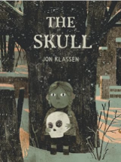

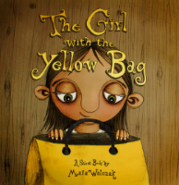

This half term sees us working on a variety of high-quality texts in our English lessons
The table below describes what is happening in each of the subject areas:
English | Our English learning will revolve around high quality texts that are on the theme of fear, family and unlikely friendships. The children will explore various spelling and grammatical features whilst studying these texts and produce short burst of writing in response to them.
Maths | Much of the half term will revolve around developing the children’s understanding of number and the number system. The children will be introduced to Times Tables rockstars to support their recall of multiplication facts.
Geography | This half term we will be learning about the mapping and the use of compasses. The children will start to become proficient in the reading of 8 point compass and grid references. The children will also learn about lines of latitude and longitude as well as revisit the importance of the equator and the poles.
History | This half term sees our children studying the Ancient Greeks for the first time. This will all start with a visitor in to school who will introduce the topic with an action-packed, hands-on learning experience. The children will go on to study Ancient Greece and how it was the birthplace of democracy as well as significant places such as Sparta and important rulers such as Alexander the Great.
Science | During our science block this term, the children will learn about the human body and the various bodily systems. They will explore the skeletal, muscular, nervous, circulatory and digestive system They will learn that some muscles, like our heart, move without us consciously thinking about it, but other muscles require us to command them to move. The children will learn that cells inside our bodies make up tissue (e.g. muscle), which make up organs, which function in systems within our bodies.
Art | This half term the children will be working on their understanding of ‘line’ in drawing. They will study various artists and famous pieces of art and use these as inspiration for developing their ability to draw. They will be taught about tone and shade. They will explore still life as a concept and apply their drawing skills to creating their own still life images.,
PE | Our PE lessons on Mondays and Fridays. Please ensure that your child comes to school dressed in appropriate PE clothing and that jewellery is removed. This half term will see the children developing their fundamental movement skills. We will be lucky enough to have the support of Rotherham Titans Rugby club in delivering some amazing PE lessons to the children mid-way through this half term.
Computing | Within computing, learners will develop their understanding of digital devices, with an initial focus on inputs, processes, and outputs. They will also compare digital and non-digital devices. Next, learners will be introduced to computer networks, including devices that make up a network’s infrastructure, such as wireless access points and switches. Finally, learners will discover the benefits of connecting devices in a network.
Music | This half term the children will learn the unit ‘Mama Mia’
PSHE | This half term the children will be learning about Being me in my world.
MFL | Our Spanish learning will be about greetings and describing ourselves and others
RE | In our RE lessons we will be thinking deeply about the following questions within Christina and Hindu faiths: What is God like? What matters most in life?
Learning you could do at home
Reading 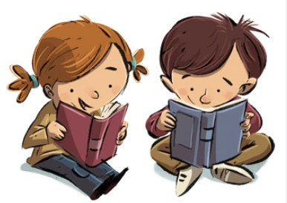
The more often your children read, the better they will get. We expect all our children to read at home for a minimum of five times a week for at least 15 minutes at a time. The more that they read, the mor confident they will become.
Not only will your child be reading within school on a daily basis, but they will also have the chance to take home a library book. Please share these with your children. They are to be read and enjoyed by all! Please feedback to us on how your child is reading at home via dojo. We value your input on your child’s reading learning at home.

If your child is still accessing phonically decodable texts, then they can access our e-library through this link and inputting their unique login details.
https://www.oxfordowl.co.uk/login?active-tab=students
If your child has been given access to Reading plus, which is an AI based platform that will support fluency, then they can access their platform through this link and input their personal details.
https://student.readingplus.com/seereader/api/sec/login

Times tables Masters
The children in year 3 and 4 are expected to learn their multiplication facts and recite them quickly. We do a lot of additional learning of this in class. Quite often, we will use TT rockstars to support your child’s learning. We would like you children to access this home on three occasions. Your child has their own login details to access this on a device. If you would prefer, we have paper copies of times tables exercises that your child can complete at home alongside you.
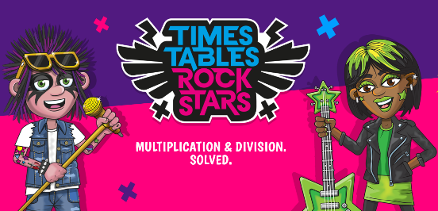
Follow this link to take you to the TT rockstars website.
https://play.ttrockstars.com/auth/school/student

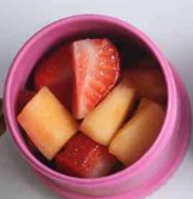
Most children like a snack at break times to get them through the morning until dinner time. We encourage children to bring in healthy snacks. Many of these will help contribute to their 5 daily portions of fruit and vegetables, keep them alert and help them concentrate. We are aiming for a common-sense approach, with the key being to keep it healthy. Examples of healthy snacks include fruit, vegetables, crackers, bread sticks, piece of cheese, yoghurt.
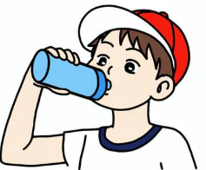
It is crucial that your child keeps hydrated during the day. Please provide a water bottle with their name on it.

If you would like any other support with learning at home please come and speak to Mr Scotton and Miss Ward.

