Year 5/6 Spring Term 2



This half term sees us working on a variety of high-quality texts subject areas that are often linked together by common themes. The wonderful texts we are going to explore this half term are:

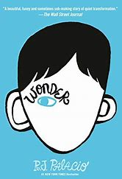

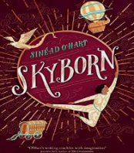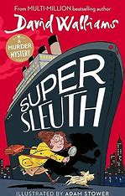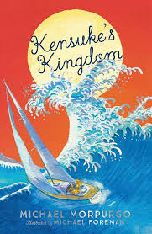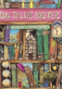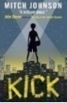

The table below describes what is happening in each of the subject areas:

|  |  |
| --- | --- |
| **English** | In English, we are using the narrative **Kick** to enhance a persuasive letter around the conditions of children other children in countries and why we think it should stop. We will use formal language with a range of vocabulary appropriate for the audience. Cohesive devices will be used across paragraph transitions, whilst using repetition of some words for impact and adverbials. |
| **Maths** | We are learning about **algebra, ratio, statistics** and **shape**. There will be a focus on reasoning questions, whilst using mathematical vocabulary to assist us with the correct operation. We will also be developing out **arithmetic skills**; using **mental methods** at speed to enable us to answer questions rapidly and correctly. |
| **Science** | During our science block this half term, we will be learning about **forces**; this includes gravity and the use of the Newton Meter. We will also conduct experiments as scientists by watching the effects of forces; measuring the impact of forces using a Newton Meter. |
| **History** | We are learning about the **Victorian Period** and **Queen Victoria**. This will enable us develop our historical knowledge in Britain, whilst developing our knowledge of the British Empire during this time. We are also, visiting The Clifton Park Museum to see historical artefacts. |
| **Art** | In Art, we are developing our techniques, whilst studying the **modern Style in Art**. |
| **PE** | We have PE lessons on **Monday** and **Thursday**. PE kit will be needed and a water bottle is recommended. |
| **PSHE** | Y5/6 are learning about **Healthy Me**; including smoking, caping, alcohol and anti-social behaviour. This will also link to a bible story in RE about how much Muslims respect their bodies and stay healthy. |
| **Computing** | Within computing, we will be learning about using **data and creating spreadsheets**. |

**Learning you could do at home**

Your child has access to a Reading Plus account and Times Tables Rockstarts account to access digital learning. They can also go on NRich, Year 5 and 6 Reasoning, convincing and proving to support with maths reasoning; as well as, Corbett Maths to practise arithmetic strtegies.

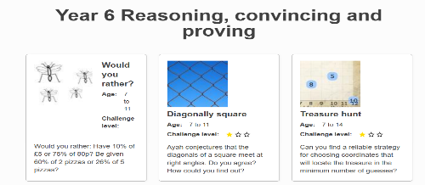

Just follow the links:

<https://nrich.maths.org/year-5-reasoning-convincing-and-proving>

<https://nrich.maths.org/year-6-reasoning-convincing-and-proving>

**Reading**

Every week your child will have access to interesting, age-related books that support what they have been learning in their reading lessons. We expect all our children to read a minimum of three times a week. Please read to your child so that you can enjoy books together. All children have access to our digital reading forum: Reading Plus, please encourage them to use this.

The more you read, the more places you will go! **Dr. Suess.**

SATs are looming very close and any additional work you take part in at home with your child, will help, please contact me if you would like any.

**If you would like any other support with learning at home please come and speak to Mrs Corker. Keep looking on Class Dojo to see photographs of our exciting learning, fun activities and events!**