**HIGHFIELD FARM PRIMARY SCHOOL**

**Writing Policy**

**Date of Policy approval _____________**

**Date of Policy review _______________**



‘When asked, “how do you write?” I invariably answer “one word at a time”.

Stephen King

Learning to be a writer is one of the most cognitively challenging but motivating things children do when they are at school. The teaching of writing at Highfield Farm Primary School is such that no matter who you are, no matter where you come from, no matter what your prior attainment, you can grow into a competent writer that takes enjoyment in its craft.

# Intent

At Highfield Farm, we have taken a holistic approach to English to ensure there is coherence between all facets of the English national curriculum. By the time the children leave our school, we hope they will have an enduring love for the subject in its own right and see English as an essential life skill which will enable them to have a successful future. The entire English curriculum has been designed to engineer success with minute steps identified in all facets of English that compliment each other at various times of the year within each year group. This writing policy is complimented by a separate reading policy but both reference each other owing to the deliberate connections between reading and writing.

It is our aim to develop not only the functional skills to be proficient writers, capable of accessing and expressing themselves within the national curriculum and beyond, but to also grow to love writing for its own worth. At Highfield Farm, writing is not just something the children have to do because it is asked of them, it is hoped that they will choose to! With this in mind, it is imperative to ensure that writing remains relevant, authentic, purposeful and valued.

The diagram below illustrates how the teaching of writing is carefully interwoven with the all the other elements of the English curriculum.

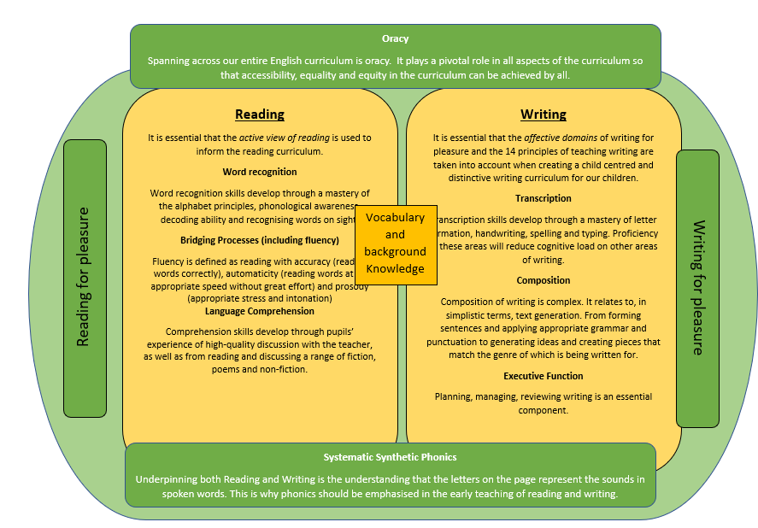

Our aim is that our children go on to apply their English skills across all subjects, but also can draw upon their knowledge from other disciplines to inform the quality of their written work. This ensures that the background knowledge and vocabulary, which is a crucial bridging component of the English model, enables all our children to express themselves with clarity and understanding in both oral and written form.

# Implementation

Based upon the National Curriculum and the individual needs of our children we have created an approach to writing that not only allows children to write for genuine purposes but also has, at its core, a high degree of response to quality texts as its main driver. From year one to year six, writing lessons are focused on a stimulus from a high-quality text, selected specifically for its richness in language, themes and grammatical demand. All chosen texts have been sequenced to take account of progression in thematic and text complexity for every half term, in every year group. The below diagram informs the choice of texts chosen as the overall driver in English writing.

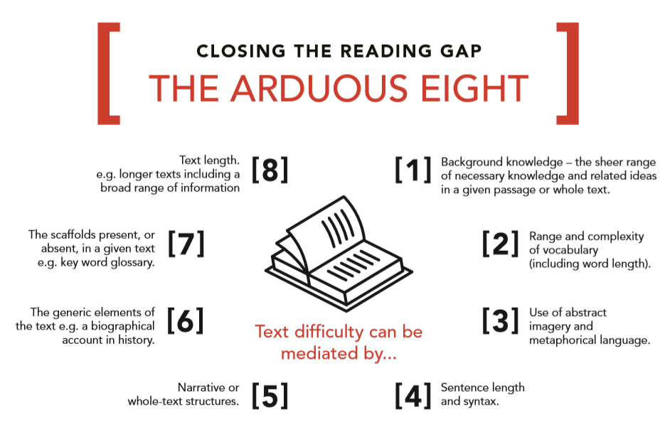

### Our English Curriculum aims to engineer success. Every objective is broken down over a year into smaller components of knowledge which not only supports from a planning perspective, but also ensures that our children are not overloaded in their short-term memory.

### During the designing of the English curriculum, all teachers worked together to select and justify the driving texts that they will choose for teaching from in their classes over the year. Careful consideration has been taken to place these texts at very specific times of the year in each year group reflecting appropriate challenge and prior background knowledge.

### **Organisation**

Our mixed-age classes access the same text, however it is the teacher’s responsibility to make adaptations so that all children can access the learning, reflecting the stage and age of the child. Our highly refined curriculum specifies the exact knowledge that is to be taught to each year group every half term even though our class make ups are within mixed age classes.

It is our firm belief that at the heart of the writing curriculum, their needs to be high enjoyment and ‘buy in’ from the children. When the conditions are right within the classroom environment, we will see an increasing proportion of children motivated to write, have a higher sense of agency over what they write and also choose to write when they are given the chance.

All writing units within the English curriculum are aimed at giving children a genuine reason to write, a purpose to express themselves with a considered audience in mind. A guiding principle is that children write as often as possible, be it a small response to a question, a skill that needs developing from the text stimulus or within application which may be extended pieces of writing. All this is reflective of the stage within the teaching sequence. This *may* be little but often in the earlier stages of the sequences of learning or time of the year. Throughout the entire sequence of lessons, transcription and composition are considered in a balanced way, as well as the crucial element of executive function and oracy.

### **Planning**

Planning for writing comes in three forms. The long term, the medium term and the short term. At all stages of the planning processes, children’s *agency* is to be considered in order to support pupil motivation in the writing they do.

***Long term planning*** - Consideration of the wider curriculum is taken into account. The English curriculum that has been set acts as the long-term plan for every year group. Teachers review what has been taught in other subject areas as this could provide essential background knowledge and vocabulary. We know from research that vocabulary and background knowledge are key in both reading and writing and so having writing units (text drivers) that are based on what has already been taught could be a guiding principle at this stage. At this stage, teachers will select the key driving texts that consider the ‘arduous eight’ principles as outlined above’. Justification and scrutiny of such texts are held to ensure there is literary challenge and progression from EYFS up to year 6. The English Curriculum has been written with a two-year cycle basis mirroring the rest of the wider curriculum delivery model.

***Medium term planning*** –Staff plan their reading and writing offer for the half term which brings together all the elements in the English curriculum model. The medium-term planning is completed and shared with the English Leader prior to the half term it is due to be delivered. This ensures that co-planning opportunities and quality assurance can be conducted. (See appendix for Medium Term Planning format).

***Short term planning*** - At this point of the planning process, staff have a degree of flexibility as to where sources of planning ideas can be sourced from. The guiding principle is that all short-term planning reflects and adheres to the English Curriculum. Teachers will make the necessary adaptations and personalisation required to suit the needs of their children. This may include increasing the amount of dialogic pedagogy in the teaching sequence, making explicit links between the reading they are doing and bringing it into the writing as well as writing their own worked examples or own personal writing. The consideration of executive function is highly prevalent at this stage. Staff are sensitive to this and employ a variety of strategies to foster a culture of effective planning, revising, editing and publishing. Each individual lesson has content that is differentiated between, and within, year groups so that learning is age-appropriate and high expectations are maintained. Individual and/or sequences of lessons should take into account the principles of instruction as laid out by Barak Rosenshine. This will add clarity and simplicity to the teaching and learning process within English. (See Appendix 3). This is not to say that every principle is to be seen in every single lesson.

### **The place of reading**

Reading is *the* central element to our approach to writing. The reading and sharing of only the very best texts inform all our children’s writing. The children will have complimentary texts that they will be exposed to that may add layers of richness to the driving text. This may be due to the link in themes, characters or historical/geographical settings. In doing so they will be exposed to the academic language of written texts and the disciplinary vocabulary in the subject. Furthermore, being exposed to rich vocabulary will add layers of quality to children’s writing as it will encourage them to apply it in their shared and independent writing. In essence, a strong principle we hold is to have ***more curriculum in the writing and not necessarily more writing in the curriculum*.**

### **The place of oracy**

### Oracy teaching at Highfield Farm Primary School is pivotal to securing equitable access to our whole curriculum. As a school we have planned a separate but complimentary half termly oracy curriculum that aims at fostering a culture of high-quality oracy within the school. We explicitly teach oracy so the children learn ‘to talk’ and ‘through talk’. The oracy framework (see appendix) is used as a tool to plan from. Within the Medium-term planning stage, all teachers identify specific areas of the framework and specific skills and activities they aim to do that will further enrichen the overall writing and reading sequence of learning.

### **The place of vocabulary and background knowledge**

Teachers use explanation and questioning, and provide opportunities for discussion and investigation to support the development of specific language and vocabulary which stems from the stimulus text. This is identified in the medium-term planning. Furthermore, staff consider what necessary background knowledge is taught prior to the writing unit being taught. Fryer Models are present in all classrooms and used as the mode of explicit vocabulary instruction.

**The place of transcription**

Transcription acts as a crucial element within the writing curriculum that must be considered in balance with composition and executive function. Whilst we aim to bring all writing into context of what the children are currently focusing on, transcription skills, in the form of handwriting and spelling, can be taught discretely. The children’s proficiency in handwriting and spelling will support overall compositional elements of writing by freeing up working memory.

**Handwriting-**The handwriting element of the curriculum has been meticulously broken down to ensure that there is very clear progression and components of knowledge identified on the English curriculum map for every year group from Year 1 to year 6.Letter families are referenced throughout KS1 and KS2 as is the development and consideration of form; letters from print form to cursive.Letter Join is our resource that we draw upon to deliver the handwriting element of the curriculum.

**Spelling-**The English curriculum identifies the very specific knowledge that is to be taughtevery single half term in every year group. Deliberate spelling objectives and conventions are taught weekly. Spelling conventions may be taught in context of the book being studied.

**Presentation-**We regard the presentation of children’s work very highly. In keeping with the principle of engineering success,very sensitive choices are made from KS1 up to year 6 as to the type of text book that the children will write in. This is in order to cultivate strong letter formation and accurate handwriting.Various books in KS1 have tracking lines and open spaces to encourage mark making for those still requiring it. Text books are used and develop progressively from Year 1 onwards that have clear ascender and descender lines that reduce in depth as the children mature.

**Dictation-** This is a crucial element of our early writing offer. In order to reduce the cognitive load on children when they write, dictated sentences are used as a supportive mechanism.Dictated sentences enable for the transcription element of writing to be developed as the composition of a sentence has been given by the adult. Handwriting and spelling are specifically to be considered during this type of activity. Specific examples of dictated sentences are identified in the English curriculum for every year group, in every half term. Dictation follows a very specific method. Each word in a sentence is isolated and then cumulatively built upon. EG:

The cat sat on a mat.

The

The cat

The cat sat

The cat sat on

The cat sat on a

The cat sat on a mat.

The complexity of dictated sentences may increase as the children become more capable of holding a sentence and remembering what has been said.

**The place of composition**

**Syntax and grammar-**This element of the teaching sequence allows all our children to practise the skills required to inform a final written piece of work. The children are taught very specific knowledge and skills to develop their ability in crafting accurate sentences. This starts in EYFS with the very smallest component of knowing what a letter and a word is and develops logically until all children can write a variety of sentence types and are aware of what elements are within it. Grammar conventions are considered that align with the text being studied. All grammar and sentence level knowledge are broken down every half term. Sentence development is always modelled to and with the children with thinking out aloud as a technique to support its composition.

**Punctuation-** The development of punctuation is broken down half termly in every year group. Consideration of the time of the year and stage of learning are made so that a logical progression in punctuation can be made. EG: Capital letters introduced at the start of the year in Year 1 as there is a heavy focus on the ‘self’ and therefore children’s names will be taught as will days of the week.

**Oral composition-** This is usedto compose sentences together and independently to orally rehearse what is to be written before it is actually written. This can be done at a sentence level, over a paragraph or as a whole text level. This is to be modelled from all staff, with explicit and deliberate self-editing orally before writing.

**Purpose, genre, form, audience-** This is considered in line with the text being studied.Each text lends itself in different ways and natural outcomes are to be derived from source texts. The purpose of writing is repeated as the year goes on so that exposure and complexity can be built cumulatively. The purposes to be focussed on in KS1 are to entertain and inform. In KS2 there is a wider selection of purpose to writing which include: to entertain, to inform, to persuade and to discuss. The genre and form of writing is planned for carefully over a sequence of learning at different times of the year for different year groups. In order to engineer success, careful consideration of writing outcomes are made that are chronologically and developmentally sensitive to a child’s writing ability.

## The place of experience lessons and exploring texts

This element of a teaching sequence allows all our children to engage with a selected text and analyse elements from it. There is a heavy focus on reading and/or oracy within this aspect where children may get the opportunity to explore authorial intent and techniques, discuss characters and settings or explore the wider context (theme or setting) of which the text is based. Within this part of the sequence there may be heavier elements of drama, speaking and listening sessions and links with other subjects and texts. Exploring the author’s use of language and vocabulary effectiveness in this aspect of the sequence is a key feature of the Highfield Farm approach to English.

## Application

This element of the teaching sequence is considered with the children’s stage of learning in mind. This consideration may be earlier on in the year or further down in the year. Moving children from being more reliant on adults to less reliant takes time and careful professional judgement. The following model is used to base the judgement to increase or decrease the independence of a child’s learning and application to learning:

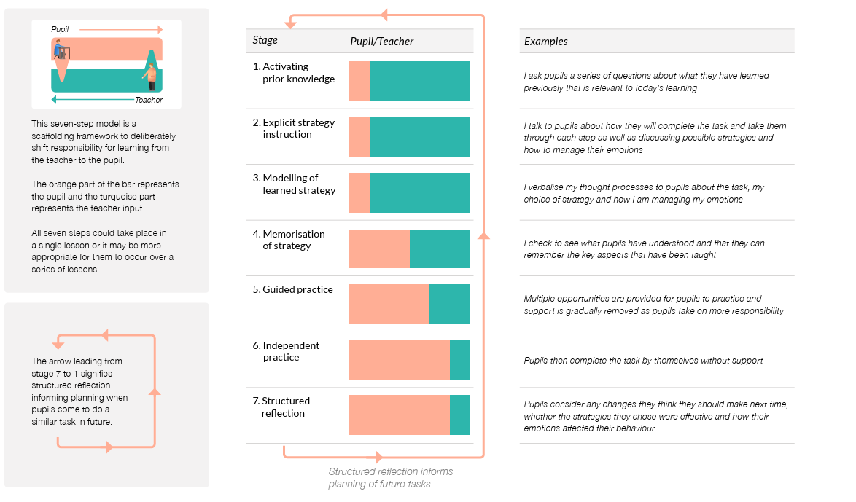

**SEND**

At Highfield Farm Primary School, every child will have the highest expectations made of them and have the opportunity to gain success in writing. High expectations are held for all children, regardless of background, prior learning or perceived ability. We see all children as writers and teach strategies that foster an increased independence and ensure that all children remain part of the writing community.

Every teacher is a teacher of SEND, and in being so, make appropriate adaptations and plans so that the children in their classrooms make progress from their starting points. In all cases, children are included within the classroom environment when subjects are taught, and this includes the English curriculum. As per the EEF’s SEND five a day recommendations, our universal provision is offered to all children. The following diagram outlines our approach to SEND provision at Highfield Farm Primary School and underpins our whole curriculum offer, including writing:

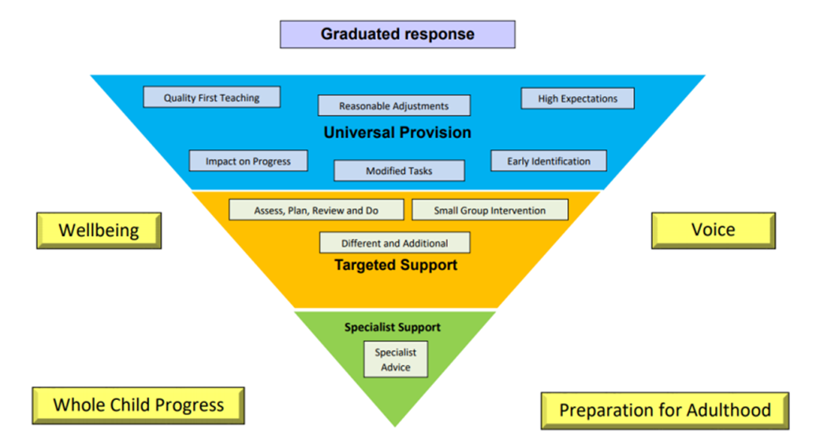

Children make progress through access to high-quality teaching in the first instance. Children are supported by the teaching staff to access whole class learning. In all classes, children have a wide range of abilities and we seek to provide learning opportunities for all children by matching the challenge of the task to the ability of the child. We achieve this through a range of strategies and adaptations. Teachers and Learning Support Assistants support children and help to remove barriers to learning. If a child’s needs require the provision of special education, the class teacher is responsible for identifying and providing this, together with support from the SENDCo and Fusion Consultants, our Learning Support Service. If a child is writing below the expectations for their age, we investigate whether this is a difficulty with motivation, enjoyment, transcription, composition or executive function and use the Birmingham Toolkit to assess and inform planning.

We use the simple view of writing as an initial means of identification of need and provide the right support to suit what the children need to learn to write, through discussions with families, teachers, SENDCo and other professionals as appropriate. See our SEND policy for more information.

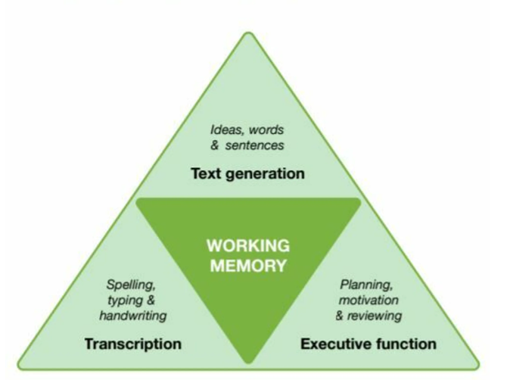

# Impact

The impact of our writing curriculum is measured in a variety of ways: questioning during lesson time, marking children’s written work, listening to child-led discussion, interviewing pupils across the school about their learning, book trawls and using images/videos of children’s practical learning.

Our school understands that our curriculum develops children’s acquisition and proficiency in their ability to write over a long period of time. Our English model enables a spiral and cumulative effect where children’s skills become deeper and more refined as the year goes on and as they move through the years in the school as a whole. Therefore, the support and scaffolding children receive will be heavier within the first half of the year and gradually the expected amount of independent work will increase. However, throughout the year teacher judgment as to how much a child needs challenging and/or supporting will inform day to day practice.

The tracking and monitoring of children’s writing is both robust and comprehensive reflecting the complexity of the subject itself. Our process to assessment and tracking is designed to improve our practice whilst capturing what a child can and cannot do and planning accordingly. It is aimed to be an inclusive model of assessment that reflects the children’s starting points and are stage and age relevant.

# Appendix One – Long term planning format-

Appendix two - Medium term planning format –

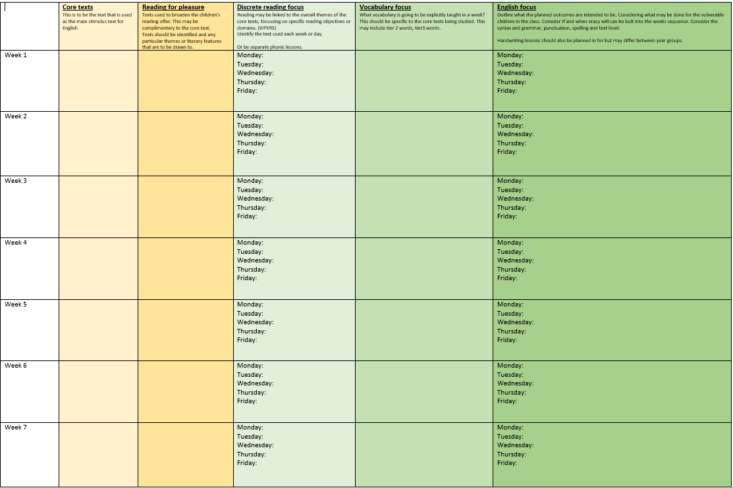

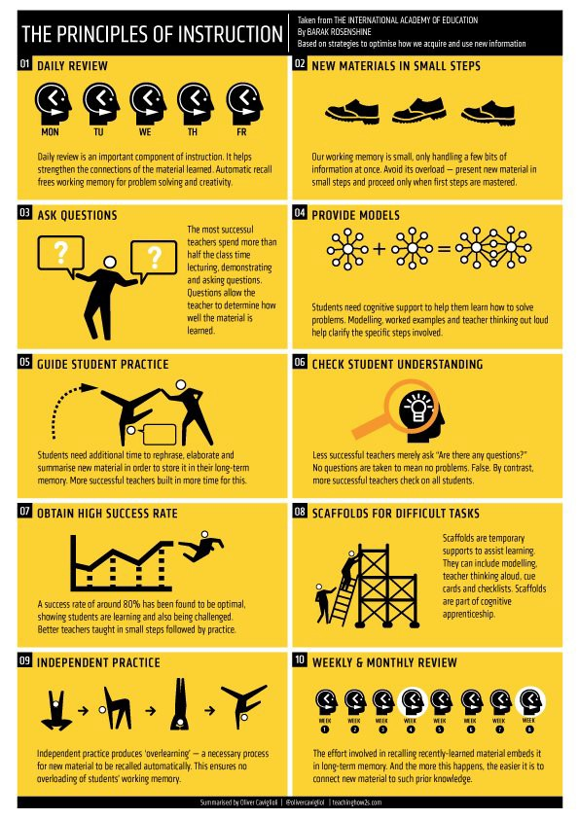Appendix 3- Rosenshine Principles