

**SEND Provision Highfield Farm Primary School**



*Together we will be kind, show respect and keep trying.*

***School Staff Expertise***

* *SENDCo*
* *School Support Worker*
* *Staff skilled in supporting autism and neurodiverse conditions*
* *Staff skilled in the delivery of speech and language programmes*
* *Team Teach trained members of staff*
* *Lego therapy trained members of staff*
* *Staff trained to deliver a range of strategies and interventions including Sensory Circuits and social stories*
* *Staff trained in SEMH and mental health*
* *Mental Health Lead*

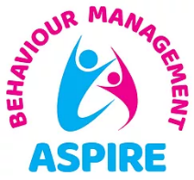

Highfield Farm Primary School has a high level of SEND at 34.9% (compared to 18% nationally) and Pupil Premium at 52% (compared to 23% nationally). We have 10 children with EHCPs in school and our attendance is 92.36%. The school’s catchment is socio-economically diverse with deprivation indicators for Health, Crime and Employment all in the lowest 20% nationally.

|  |  |  |  |  |
| --- | --- | --- | --- | --- |
| Implementation: School Steps to Success | | | | |
| Provision | Communication and Interaction | Cognition and Learning | Social, Emotional and Mental Health | Sensory and Physical |
| Universal | Quality First Teaching  Meeting with parents  One Page Profile  Communication in Print  Clicker  Same-day intervention.  Zones of Regulation | Quality First Teaching  Meeting with parents  One Page Profile  Communication in Print  Clicker  Same-day intervention  Zones of Regulation | Quality First Teaching  Meeting with parents  One Page Profile  Communication in Print  Clicker  Same-day intervention  Zones of Regulation | Quality First Teaching  Meeting with parents  One Page Profile  Communication in Print  Clicker  Same-day intervention  Zones of Regulation |
| Targeted | As above and also:  Regular meetings with parents  SALT programmes  Teacher-devised specific interventions.  Specific support for language and communication difficulties.  Early Help if applicable. | As above and also:  Regular meetings with parents  Teacher-devised specific interventions.  Published support programmes.  Early Help if applicable. | As above and also:  Regular meetings with parents  Teacher-devised specific interventions  Published support programmes (e.g. Lego therapy, Anger Gremlins, Emotional Scales)  Early Help if applicable. | As above and also:  Regular meetings with parents  Teacher-devised specific interventions  OT devised programmes.  Early Help if applicable. |
| Specialist | As above and also:  Fusion LSS  Autism SALT support  EPS | As above and also  Fusion LSS  EPS | As above and also:  Behaviour Support e.g. Aspire Outreach  EPS  Bereavement support | As above and also:  Occupational Therapy  Hearing and Visual Impairment Team |

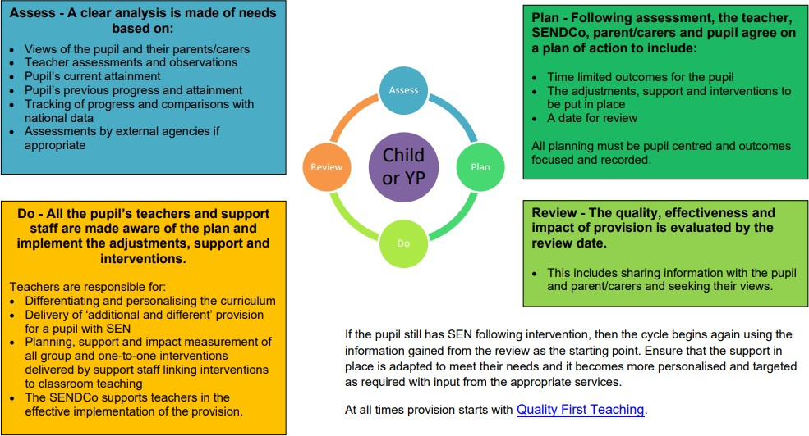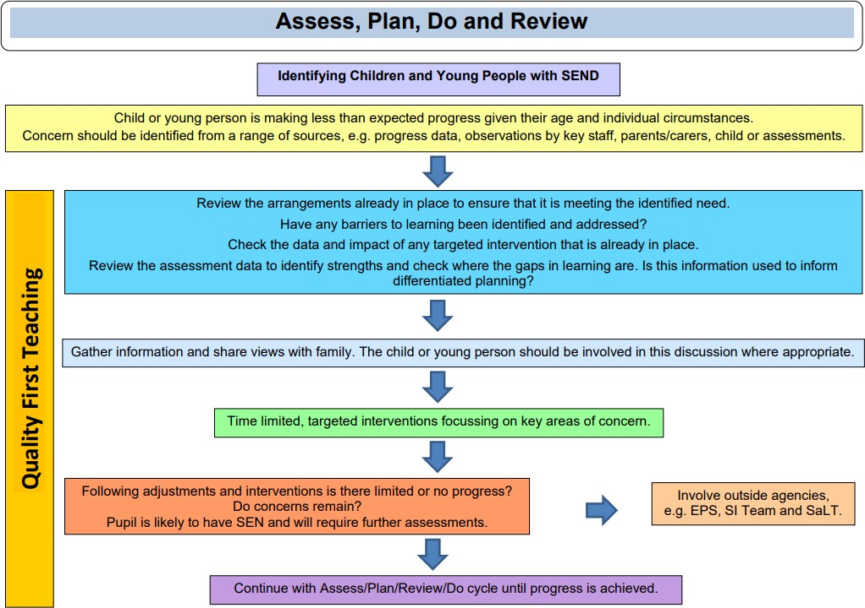

This term staff have received CPD in these areas of SEND:

* Zones of Regulation
* Birmingham Toolkit
* Evidence for Learning

**Impact:** As a result, Children at Highfield Farm:

* feel happy, safe and respected.
* Behaviour is good and diversity is celebrated.
* Children demonstrate high levels of engagement in activities, developing their speaking, listening and social skills.
* Have supportive and trained staff who make appropriate for the child’s individual needs. ·
* Children with SEND make good progress from their starting points due to Quality First Teaching and to the use of resources and bespoke small group intervention which meets the needs of the pupils.
* On leaving our school children with SEND have developed good independence and life skills. · Pupils will make secure transitions between classes and educational providers e.g. EYFS or High School.

***Intent****: Everyone at Highfield Farm Primary School is committed to, and passionate about, providing the conditions and opportunities to enable every child, including those with additional needs, to be included fully, in all aspects of school life. We believe in the earliest possible intervention to support our children and families. We always start with Quality First Teaching, for all children. If support is required beyond this, a graduated response is at the heart of our whole school ‘steps to success’ practice. We continually assess, plan, implement and review our approach to teaching and learning collaboratively with parents. We have highly skilled and trained staff to support any additional needs and use expert support from outside agencies where needed.*