**HIGHFIELD FARM PRIMARY SCHOOL**

**Oracy Policy**

**Date of Policy approval _____________**

**Date of Policy review _______________**



‘In school, oracy is a powerful tool for learning; by teaching students to become more effective speakers and listeners we empower them to better understand themselves, each other and the world around them. It is also a route to social mobility, empowering all students, not just some, to find their voice to succeed in school and life.’

Voice 21

Learning to speak with confidence and communicate effectively, is the cornerstone of our entire curriculum. Through a high-quality oracy education students learn ‘through talk’ and ‘to talk’. This is when they develop and deepen their subject knowledge and understanding through talk in the classroom, which has been planned, designed, modelled, scaffolded and structured to enable them to learn the skills needed to talk effectively. At Highfield Farm Primary School oracy is placed as the highest of priorities.

# Intent

At Highfield Farm, we have taken a holistic approach to oracy and see it as a crucial component to the delivery of all curriculum subjects. Whilst we have a specific curriculum to develop oracy skills and teach children to talk, we also use oracy to develop the understanding of the wider curriculum. By the time the children leave our school, we hope they will have the spoken language skills to successfully access the whole curriculum and go on into the future as confident, well-spoken citizens. Whilst it plays an all-encompassing role in the wider curriculum, it has a crucial role within the English curriculum. The quality and variety of language that the children hear and speak is vital for developing their vocabulary, grammar and their understanding for reading and writing.

Oracy is the ability to communicate effectively by articulating ideas, develop understanding and engage with others through spoken language. We want every child to find their voice. Our aim is to remove communication barriers and enable children to be confident and effective communicators by the end of primary school.

Our aims for oracy for all our children are:

• To achieve high levels of participation in dialogue – all actively participate

• To share relevant information

• To respect each other’s ideas and views

• To encourage children to elaborate their ideas

• To encourage questioning and challenging

• To check understanding by asking questions

• To engage critically but constructively with each other’s ideas

• To build on each other’s responses

• To learn the skills of language for life

• To improve children’s attainment and reasoning skills

The diagram below illustrates how the teaching of oracy is carefully interwoven with the all the other elements of the English curriculum.

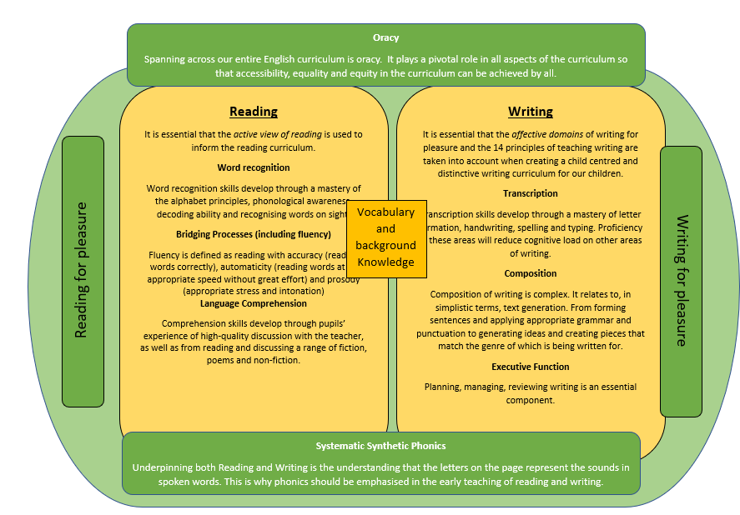

Our aim is that our children go on to apply their oracy skills across all subjects, and not just within English lessons. The background knowledge that we teach and vocabulary that we expose the children to, will be drawn upon using oracy as the vehicle. By enabling children to talk, we are guaranteeing that more children can access the curriculum and express themselves with greater confidence.

# Implementation

### Oracy teaching at Highfield Farm Primary School is pivotal to securing equitable access to our whole curriculum. As a school we have planned a separate but complimentary half termly oracy curriculum that aims at fostering a culture of high-quality oracy within the school. We explicitly teach oracy so the children learn to talk and through talk

Pupils are taught oracy skills during dedicated lessons during the sequences of learning, every week. This may be within the English sequence of learning or within other subject area. During these sessions pupils are taught a range of listening skills, vocabulary and discussion techniques. They have the opportunity to experience a range of talking styles – from exploratory talk to presentational talk which get progressively more challenging as the year progresses in each year group and key stage.

We use the oracy framework to identify the oracy skills that are required for effective speaking and listening and have created a curriculum map that breaks these skills down further for every year group in every half term.

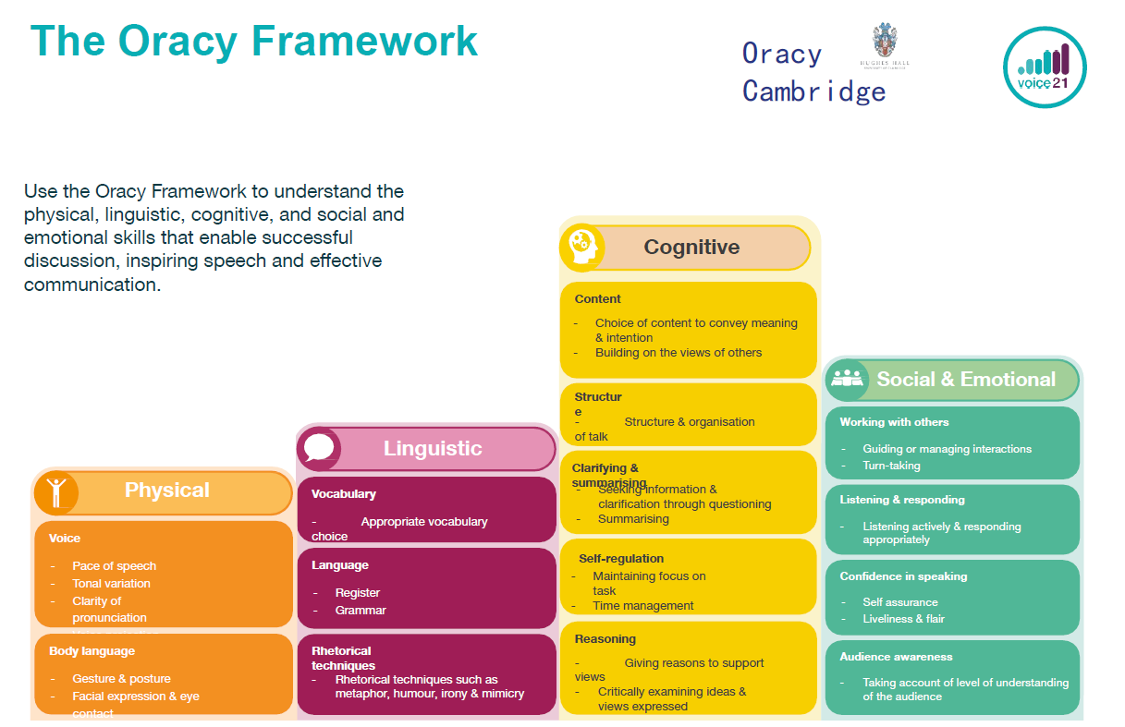

This frameworks allows both staff and pupils to understand what makes good spoken communication. The four strands enable successful discussion, inspiring speech and effective communication. The framework is used by staff to give feedback and assess progress. Pupils use the framework to self-assess, peer-assess and talk about talk.

**Oracy in English**

As a school we are committed to raising and maintaining high standards in English. We support our pupils by providing them with the skills necessary to:

• Develop and build vocabulary

• Participate in collaborative conversations

• Articulate and justify their answers

• Participate in discussions, presentations, performances, role play, improvisations and debates

• Speak audibly and fluently with an increasing command of Standard English

• Give well-structured descriptions, explanations and narratives for different purposes

Oracy is a fundamental element of our English curriculum model. It is incorporated into English lessons in the following ways:

• Drama and role play

• Asking and answering questions

• Group discussion

• Vocabulary activities

• Partner talk

• Presentation of work

**Oracy across the curriculum**

Oracy is incorporated across our broad and balanced curriculum to develop understanding and higher order thinking. It supports pupils to make their thinking clear to themselves as well as others. Oracy is carefully planned into sessions that add value to the sequence of learning. Oracy and talk activities are central to the wider curriculum as it provides ALL pupils to learn the content that is being delivered and removes barriers to participation. Questions and tasks are differentiated to ensure full participation and pupil discussions are scaffolded to ensure inclusive practice.

### **Organisation**

Children in the mixed classes access the same subject content, however it is the teacher’s responsibility to make adaptations so that all children can access the learning, reflecting the stage and age of the child. Our highly refined oracy curriculum specifies the exact knowledge that is to be taught to each year group every half term even though our class make ups are within mixed age classes.

It is our firm belief that at the heart of the oracy curriculum, there needs to be high enjoyment and ‘buy in’ from the children. When the conditions are right within the classroom environment, we will see an increasing proportion of children motivated to talk, have a higher sense of agency over what they say and also choose to talk when they are given the chance.

**Discussion Guidelines**

Each class has developed their own set of ‘Talk Rules’ specific to their talk skills. These are a set of guidelines for partner and group discussion that help to maintain an effective and respectful environment for talk. Different features are focussed upon weekly, to build up skills and support a wide range of talk.

### **Planning**

Planning for oracy comes in three forms. The long term, the medium term and the short term. At all stages of the planning processes, children’s *agency* is to be considered in order to support pupil motivation in the writing they do.

***Long term planning*** - Consideration of the wider curriculum is taken into account. The oracy curriculum that has been set acts as the long-term plan for every year group. Teachers review what has been taught or what is about to be taught in other subject areas as this could provide stimulus for oracy tasks.

***Medium term planning*** –. At this point, staff plan their oracy offer for the half term which brings together all the elements in the English curriculum model and consider where oracy development might best fit into the wider curriculum subjects.

***Short term planning*** - Staff have a degree of flexibility as to where sources of planning ideas can be sourced from. Oracy tasks can be drawn from the voice 21 dashboard or from activities stored on the staff shared drive. The guiding principle is that all short-term planning has embedded within its sequence of learning, elements of oracy. Teachers will make the necessary adaptations and personalisation required to suit the needs of their classrooms. In every oracy lesson, the skills that are to be taught and focussed on as well as the type of talking roles and talking groups, are to be made clear to the children. See Appendix.

### **The place of vocabulary and background knowledge**

Teachers use explanation and questioning, and provide opportunities for discussion and investigation to support the development of specific language and vocabulary which stems from the curriculum content / unit being taught. Such vocabulary is identified in the medium-term planning that specifically to be taught. Fryer Models are present in all classrooms and used as the mode of explicit vocabulary instruction and as an aide memoir in oracy lessons.

## Application

This element of the teaching sequence is considered with the children’s stage of learning in mind. This consideration may be earlier on in the year or further down in the year. Moving children from being more reliant on adults to less reliant takes time and careful professional judgement. The following model is used to base the judgement to increase or decrease the independence of a child’s learning and application to learning.

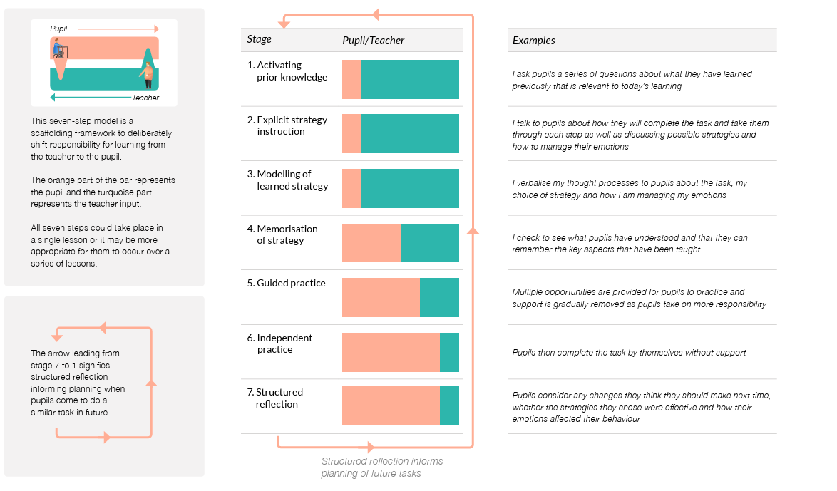

**Celebration of Oracy**

Oracy is rewarded with dojo points across the school. A weekly Oracy Master certificate is given out in the whole school celebration assembly. This ensures that oracy is kept at a high profile within the school

**SEND**

Every child will have the highest expectations made of them and have the opportunity to gain success in oracy. High expectations are held for all children, regardless of background, prior learning or perceived ability. We see all children as speakers and teach strategies that foster an increased independence and ensure that all children remain part of the oracy community. Children with additional needs take a full and active part in spoken language activities at a level appropriate for their needs. Some pupils access small group or individual sessions with a TA or teacher to encourage children to practise sentences.

Every teacher is a teacher of SEND, and in being so, make appropriate adaptations and plans so that the children in their classrooms make progress from their starting points. In all cases, children are included within the classroom environment when subjects are taught, and this includes the oracy curriculum. As per the EEF’s SEND five a day recommendations, our universal provision is offered to all children. The following diagram outlines our approach to SEND provision at Highfield Farm Primary School and underpins our whole curriculum offer, including writing.

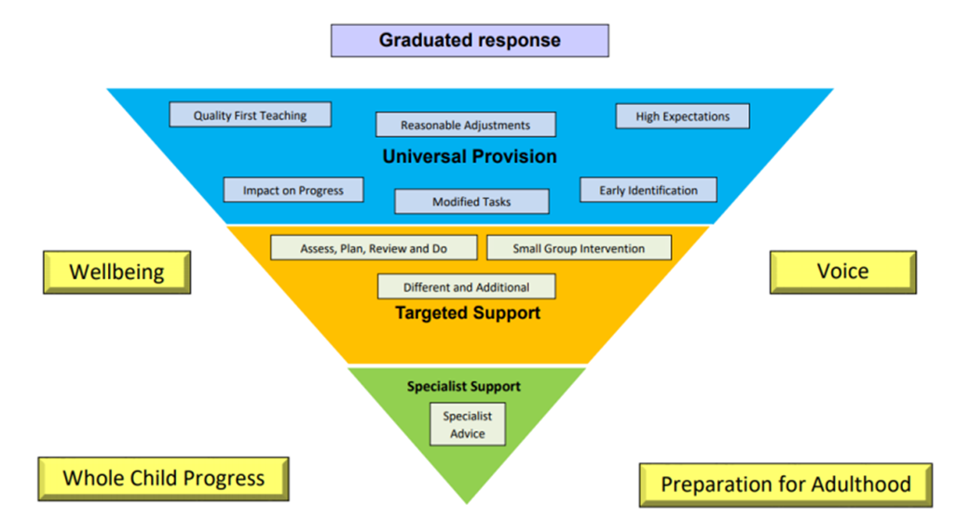

# Impact

The impact of our curriculum is measured in a variety of ways: questioning during lesson time, critiquing children’s oral contributions work, listening to child-led discussion, interviewing pupils across the school about their learning.

Our school understands that our curriculum develops children’s acquisition and proficiency in their ability to talk over a long period of time. Our oracy model enables a spiral and cumulative effect where children’s skills become deeper and more refined as the year goes on and as they move through the years in the school as a whole. Therefore, the support and scaffolding children receive will be heavier within the first half of the year and gradually the expected amount of independence work will increase. However, throughout the year teacher judgment as to how much a child needs challenging and/or supporting will inform day to day practice.