Half term 1: PSHE Narrative, Non-fiction animation on the history of Lego |  | Half term 2: A dark narrative fairy tale, a humorous adventure animation |  | Half term 3: Character description, persuasive speech
Key texts(s): Up, The Lego Story  Outcomes:  - Re-tell Narrative  - Produce a Non-chronological report on a toy  First hand experiences: Balloons, new friendships, create friendship bracelets, lego building experience  Key terminology: Emotive language, symbolism, |  | Key texts(s): Hansel and Gretel, Kevin the Carrot 2020 animation  Outcomes:  - Write Kevin’s next diary entry using informal language.  - Narrative re-tell  First hand experiences: Role-play, Hot-seating, Create their own Kevin the Carrot  Key terminology: Genre specific vocabulary, mood, atmosphere, tensions, stylistic devices, figurative language. |  | Key texts(s): Ruin animation and Stitch Head  Outcomes:  - Character description  - Persuasive speech  First hand experiences: Lego minifigures to design characters, Inside Out emotion characters, watch extract from film, Playdoh to create their own creature, Lego to design a different creature to enhance descriptive language  Key terminology: Technical vocabulary, range of sentence types, adverbial phrase, prepositional phrase, paragraphs, verb tenses, direct and reported speech, range of conjunctions, expanded noun phrases.
Writing skills  Composition:  In narratives, describe settings, characters and atmosphere. Maintain legibility in joined handwriting when writing at speed. Select vocabulary and grammatical structures that reflect what the writing requires, doing this mostly appropriately (e.g. using contracted forms in dialogues in narrative; using passive verbs to affect how information is presented; using modal verbs to suggest degrees of possibility). Use the range of punctuation taught at key stage 2 mostly correctly. |  | Writing skills  Composition:  Write effectively for a range of purposes and audiences, selecting language that shows good awareness of the reader (e.g. the use of the first person in a diary; direct address in instructions and persuasive writing). Integrate dialogue in narratives to convey character and advance the action. Use a range of devices to build cohesion (e.g. conjunctions, adverbials of time and place, pronouns, synonyms) within and across paragraphs. |  | Writing skills  Composition:  Use a range of devices to build cohesion (e.g. conjunctions, adverbials of time and place, pronouns, synonyms) within and across paragraphs. Use verb tenses consistently and correctly throughout their writing. Use the range of punctuation taught at key stage 2 mostly correctly^ (e.g. inverted commas and other punctuation to indicate direct speech).
Images from texts being used in this section  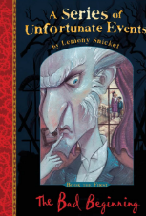  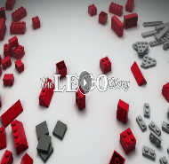  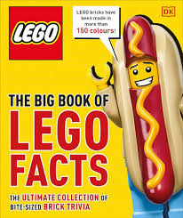  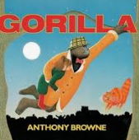  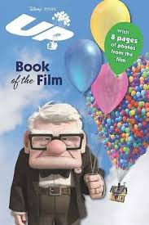 |  |   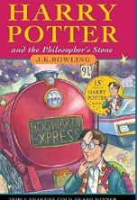  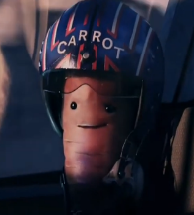  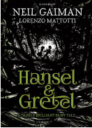  Images from texts being used in this section |  | Images from texts being used in this section  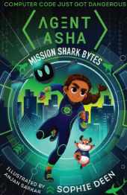    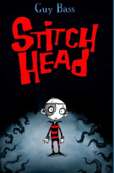  
Spoken language  To listen carefully, making timely contributions and asking questions that are responsive to others’ ideas and views, e.g. participate in a collaborative project where they listen to the ideas of others and adapt these to meet the needs of the group  To develop, agree to and evaluate rules for effective discussion; follow their own rules in small groups and whole- class conversations  To regularly use interesting adjectives, adverbial phrases and extended noun phrases in speech.  Reading links  maintain positive attitudes to reading and an understanding of what they read by continuing to read and discuss an increasingly wide range of fiction, poetry, plays, non-fiction and reference books or textbooks. Reading books that are structured in different ways and reading for a range of purposes. Increasing their familiarity with a wide range of books, including myths, legends and traditional stories, modern fiction, fiction from our literary heritage, and books from other cultures and traditions. | GPS links  Handwriting: Maintain legibility in joined handwriting when writing at speed  Grammar:  Use of modal verbs to suggest degrees of possibility.  Relative clauses beginning with who, which, where, when, whose, that, or an omitted relative pronoun.  Punctuation:  Commas to indicate parenthesis. Use of commas to clarify meaning or avoid ambiguity. Punctuation of bullet points to list information.  Spellings:  Endings which sound like  ʃspelt –cious or –tious / əs/  Endings which sound like- cial.  Words ending in –ant, –ance/–ancy, –ent, –ence/–ency | Spoken language  To understand how to answer questions that require more detailed answers and justification  To use feedback from peers and teachers (and from observing other speakers) to make improvements to performance  To combine vocabulary choices, gestures and body movement to take on and maintain the role of a character.  To ask questions, offer suggestions, challenge ideas and give opinions in order to take an active part in discussions.  Reading links  Recommending books that they have read to their peers, giving reasons for their choices. Identifying and discussing themes and conventions in and across a wide range of writing. Making comparisons within and across books. Learning a wider range of poetry by heart. Preparing poems and plays to read aloud and to perform, showing understanding through intonation, tone and volume so that the meaning is clear to an audience. | GPS links  Handwriting: Choosing which shape of a letter to use when given choices and deciding whether or not to join specific letters. Choosing the writing implement that is best suited for a task.  Grammar:  Converting nouns or adjectives into verbs using suffixes [for example, –ate; –ise; –ify]  Verb prefixes [for example, dis–, de–, mis–, over– and re–]  Punctuation:  Use of the semi-colon, colon and dash to mark the boundary between independent clauses [for example, It’s raining; I’m fed up]  Spellings:  modal verb, relative pronoun  The –able/–ably endings are far more common than the –ible/–ibly endings.  As with –ant and –ance/–ancy, the –able ending is used if there is a related word ending in –ation. | Spoken language  To recognise powerful vocabulary in stories/ texts that they read or listen to, building these words and phrases into their own talk in an appropriate way  To narrate stories with intonation and expression to add detail and excitement for the listener.  Reading links  Understand what they read by checking that the book makes sense to them, discussing their understanding and exploring the meaning of words in context. Asking questions to improve their understanding. Drawing inferences such as inferring characters’ feelings, thoughts and motives from their actions, and justifying inferences with evidence. Predicting what might happen from details stated and implied. | GPS links  Handwriting: Pupils should continue to practise handwriting and be encouraged to increase the speed of it, so that problems with forming letters do not get in the way of their writing down what they want to say.  Grammar:  Devices to build cohesion within a paragraph [for example, then, after that, this, firstly]  Linking ideas across paragraphs using adverbials of time [for example, later], place [for example, nearby] and number [for example, secondly] or tense choices [for example, he had seen her before]  Punctuation:  Brackets, dashes or commas to indicate parenthesis.  Use of commas to clarify meaning or avoid ambiguity  Spellings:  Adding suffixes beginning with vowel letters to words ending in –fer.  The r is doubled if the –fer is still stressed when the ending is added.  The r is not doubled if the –fer is no longer stressed.
Half term 4: Journalistic, imaginative |  | Half term 5: Non-Fiction, Spooky narrative |  | Half term 6: non-chronological report, setting description
Key texts(s):  Kick by Mitch Johnson, How to live forever by Colin Thompson  Outcomes:  - Persuasive Letter  - Balanced argument  First hand experiences:  Watch a football clip to collect vocabulary, visual Lego football stadium, hot seating, conversation alley, a variety of fiction and non-fiction books,  Key terminology: : Range of conjunctions, range of sentence types, relative clause, expanded noun phrases, rhetorical questions, colons, semi colons, commas for clarity, brackets, dashes, technical language |  | Key texts(s):  Darwin’s Dragons by Lindsay Galvin, Werner’s nomenclature of colour, Thornhill by Pam Smy  Outcomes:  - Biography  - Diary  First hand experiences:  Walk to the graveyard and explore overgrown grass, broken toys, games and objects, keep out sign, Werner’s nomenclature of colour, instruments to recreate sounds from the island, craft eggs  Key terminology: Genre specific language, figurative language, metaphor, simile, personification, mood, atmosphere, tension |  | Key texts(s):  The Emperor Penguin’s non-chronological report by Jane Considine, Alma  Outcomes:  - Non-chronological report on polar bears  - Setting description  First hand experiences:  An old doll, Toy shop (Lego), objects to trigger the 5 senses, emperor penguin, watch a clip of emperor penguins, children create a scene from the clip, blubber experience with ice,  Key terminology: hyperbole (exaggerate), emotive vocabulary, audience and purpose, humour
Writing skills  Composition:  Spell correctly most words from the year 5 / year 6 spelling list, and use a dictionary to check the spelling of uncommon or more ambitious vocabulary. Maintain legibility in joined handwriting when writing at speed. Identifying the audience for and purpose of the writing, selecting the appropriate form and using other similar writing as models for their own. Noting and developing initial ideas, drawing on reading and research where necessary. In writing narratives, considering how authors have developed characters and settings in what pupils have read, listened to or seen performed. |  | Writing skills  Composition:  Selecting appropriate grammar and vocabulary, understanding how such choices can change and enhance meaning. In narratives, describing settings, characters and atmosphere and integrating dialogue to convey character and advance the action. Précising longer passages and using a wide range of devices to build cohesion within and across paragraphs. Using further organisational and presentational devices to structure text and to guide the reader [for example, headings, bullet points, underlining] |  | Writing skills  Composition:  Assessing the effectiveness of their own and others’ writing. Proposing changes to vocabulary, grammar and punctuation to enhance effects and clarify meaning. Ensuring the consistent and correct use of tense throughout a piece of writing. Ensuring correct subject and verb agreement when using singular and plural, distinguishing between the language of speech and writing and choosing the appropriate register. Proofread for spelling and punctuation errors. Perform their own compositions, using appropriate intonation, volume, and movement so that meaning is clear.
Images from texts being used in this section  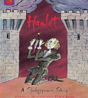    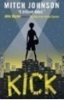 |  | Images from texts being used in this section  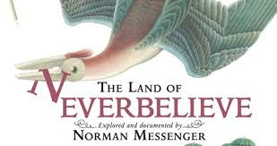  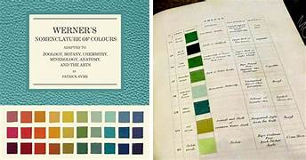  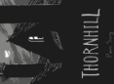  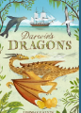 |  | Images from texts being used in this section  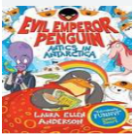  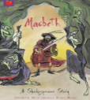  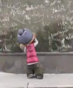  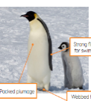
Spoken language  To listen carefully, making timely contributions and asking questions that are responsive to others’ ideas and views, e.g. participate in a collaborative project where they listen to the ideas of others and adapt these to meet the needs of the group  To develop, agree to and evaluate rules for effective discussion; follow their own rules in small groups and whole- class conversations  To regularly use interesting adjectives, adverbial phrases and extended noun phrases in speech.  Reading links  Summarising the main ideas drawn from more than 1 paragraph, identifying key details that support the main ideas. Identifying how language, structure and presentation contribute to meaning. Discuss and evaluate how authors use language, including figurative language, considering the impact on the reader. | GPS links  Handwriting: They should be clear about what standard of handwriting is appropriate for a particular task, for example, quick notes or a final handwritten version.  Grammar:  The difference between vocabulary typical of informal speech and vocabulary appropriate for formal speech and writing [for example, find out – discover; ask for – request; go in – enter]  How words are related by meaning as synonyms and antonyms [for example, big, large, little].  Punctuation:  Linking ideas across paragraphs using a wider range of cohesive devices: repetition of a word or phrase, grammatical connections [for example, the use of adverbials such as on the other hand, in contrast, or as a consequence], and ellipsis  Layout devices [for example, headings, sub-headings, columns, bullets, or tables, to structure text]  Spellings:  Use of the hyphen.  Words with the /i:/ sound spelt ei after c.  Words containing the letter-string ough. | Spoken language  To understand how to answer questions that require more detailed answers and justification  To use feedback from peers and teachers (and from observing other speakers) to make improvements to performance  To combine vocabulary choices, gestures and body movement to take on and maintain the role of a character.  To ask questions, offer suggestions, challenge ideas and give opinions in order to take an active part in discussions.  Reading links  Distinguish between statements of fact and opinion. Retrieve, record and present information from non-fiction. Participate in discussions about books that are read to them and those they can read for themselves, building on their own and others’ ideas and challenging views courteously. | GPS links  Handwriting: They should also be taught to use an unjoined style, for example, for labelling a diagram or data, writing an email address, or for algebra, and capital letters, for example, for filling in a form.  Grammar:  Use of the passive to affect the presentation of information in a sentence [for example, I broke the window in the greenhouse versus The window in the greenhouse was broken (by me)].  Punctuation:  Punctuation of bullet points to list information  How hyphens can be used to avoid ambiguity [for example, man eating shark versus man-eating shark, or recover versus re-cover]  modal verb, relative pronoun, relative clause  parenthesis, bracket, dash, ambiguity  Spellings:  Words with ‘silent’ letters (i.e. letters whose presence cannot be predicted from the pronunciation of the word). | Spoken language  To recognise powerful vocabulary in stories/ texts that they read or listen to, building these words and phrases into their own talk in an appropriate way  To narrate stories with intonation and expression to add detail and excitement for the listener.  Reading links  Explain and discuss their understanding of what they have read, including through formal presentations and debates, maintaining a focus on the topic and using notes where necessary. Provide reasoned justifications for their views. | GPS links  Handwriting: write legibly, fluently and with increasing speed by choosing which shape of a letter to use when given choices and deciding whether or not to join specific letters. Choosing the writing implement that is best suited for a task.  Grammar:  The difference between structures typical of informal speech and structures appropriate for formal speech and writing [for example, the use of question tags: He’s your friend, isn’t he?, or the use of subjunctive forms such as If I were or Were they to come in some very formal writing and speech]  Punctuation:  Use of the semi-colon, colon and dash to mark the boundary between independent clauses [for example, It’s raining; I’m fed up]  Use of the colon to introduce a list and use of semi-colons within lists  subject, object, active, passive, synonym, antonym, ellipsis, hyphen, colon, semi-colon, bullet points  Spellings:  Homophones and other words that are often confused.

