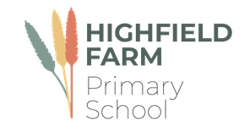

Foundation Stage

Autumn Term 1

This term sees us working on a variety of high-quality texts that are often linked together by common themes. The wonderful texts we are going to explore this term are:

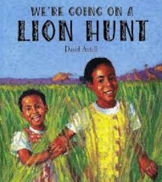 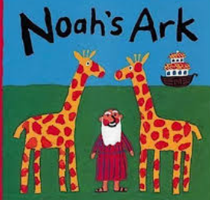 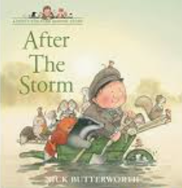 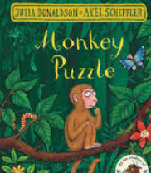 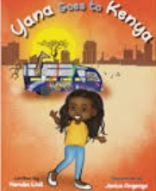

The table below describes what is happening in each of the subject areas.

|  |  |
| --- | --- |
| **Communication and Language** | This half term we will be having lots of circle time so we can work on our turn taking and interacting with adults and our peers. We will be introducing new vocabulary such as **weather, seasons, spring, summer, autumn and winter** and discussing which each one means. |
| **Personal, social and emotional development.** | In our weekly Jigsaw lessons we will be looking at how it feels to belong and that we are similar and different to each other. We will begin to look at our feelings and try to name them. |
| **Maths** | During the first half-term we will be matching objects, looking at patterns and start to look at numbers to 5/10. |
| **Literacy** | We will be working hard on holding our pencil correctly in order to mark make. The children will be given lots of opportunities to mark make using different media such as pencils, pens and paint. |
| **PE** | Please make sure that your children come to school dressed in **full PE kit to school every Tuesday and Thursday** including tracksuit bottoms and tops and suitable footwear. The children will be participating in a variety of fundamental movement skills and gymnastics. |
| **Music** | In music we will be following the Charanga music scheme, we will be learning nursery rhymes and using our voice as an instrument. We will begin to understand that a performance is sharing music and the purpose of a performance is to entertain others. |
| **RE** | This half term we will be looking at Noah’s Ark. |
| **Expressive arts and design** | In Art we will be creating self portraits using lines to make features using thick and thin brushes for adding detail. In DT we will be collecting apples from the nursery garden tree and baking our own apple pie. |
| **KUW** | We will be learning about the country Kenya and where this is in the world. We will be looking as the weather, food and celebrations they have as part of their culture. |

**Learning you could do at home**

Reading

Every week your child will have access to a bedtime story book. Please spend time at home looking at the story and discussing with your child what they think is happening and what they think might happen next. Encourage your child to create their own story using the pictures as well as listen to you read the story to them.

**Our school library**

The school has a library of books that the children can borrow from and enjoy at home. The books they choose are to be enjoyed by the whole family. These books may be too difficult for your child to read on their own and so we recommend that the books are read to them by an adult.

The school website also has a virtual library which has some recommended reads for all our children in virtual and video format. These books will be changed every half term.

**Home Learning**

Go for a walk close to home that has signs of Autumn such as a local wood. Ask your child what they can see and hear. Can they here crunching leaves under their feet or the whistling of the wind through the trees? Can you collect objects to bring to class that show signs of Autumn such as conkers and different coloured leaves.

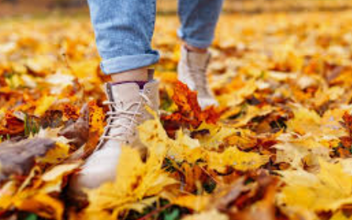 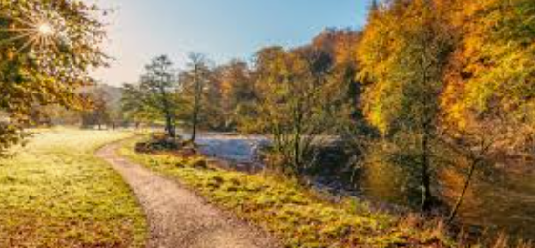

We would love to celebrate home learning, please send in any work or why not send us a photo on Dojo.