Year 5/6 Autumn Term
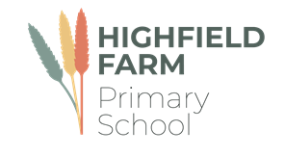

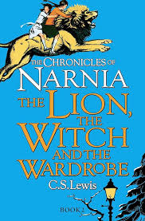
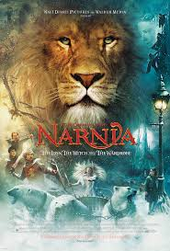
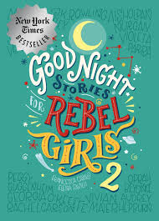
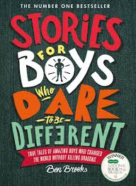
This half term sees us working on a variety of high-quality texts subject areas that are often linked together by common themes. The wonderful texts we are going to explore this half term are:
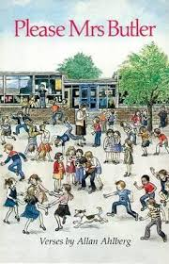
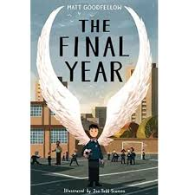
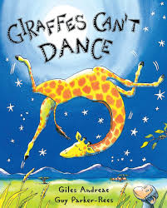
The table below describes what is happening in each of the subject areas:
English | In English, as a transition activity we are sharing Giraffes Can’t Dance, to open the discussion about we can’t do something yet and that is how we grow and develop. The children will be showcasing their previous years writing skills to write themselves instructions on how to complete a task that they can’t do yet. We will also explore rhyming and write our own verse with a rhyming element.  For our core English text, we are exploring Narnia: The Lion, The Witch and The wardrobe, a classic narrative. This story will link to our World War 1 topic, whilst developing the children’s imagination, vocabulary and expressive language. To launch this story, we will also be watching the film, alongside reading the book.
Maths | We are leaning about place value; extending our knowledge to 7-digit numbers including counting through zero to negative numbers. Using these number facts, we will be learning how to use addition subtraction, multiplication and division strategies with greater values. Finishing off with fractions.  There will also be a focus on telling the time using an analogue watch. If your child has an analogue watch, please allow them to wear it for school.
Science | During our science block this term, we will be learning about the human body and other living things. We may even have a class pet or two to support with this topic.
History | We are learning about World War One, which is included in our English narrative. This unit will explore human rights and lead into the Suffragettes.
DT | In DT, we are learning to sew and recycling old t-shirts into designer pieces.
PE | We have PE lessons on Tuesday and Thursday afternoons. PE kit will be needed and a water bottle.
PSHE | Y5/6 are learning about being me in my world. If your child has a unique quality or feature, please encourage them to share this, so we can promote unique individualism.
Computing | Within computing, we will be learning about computer systems and networks. This will include internet safety.
R.E | In Religious Education, we will be comparing Islamic Relief and Christian Aid. We will be exploring how much impact these charities make throughout the world.
Music | Our song In Music is Happy this half term, where children will learn about different genres of music and their history.
PSHE | Being me in my world, is our topic in PSHE, where we will explore a positive image about each other and promote diversity.
MFL | Our modern foreign language is Spanish and we will be learning how to describe ourselves and others.

Learning you could do at home
Reading
Every week your child will have access to interesting, age-related books that support what they have been learning in their reading lessons. We expect all our children to read a minimum of three times a week. Please read to your child so that you can enjoy books together. All children have access to our digital reading forum: Reading Plus, please encourage them to use this.
The more you read, the more places you will go! Dr. Suess

Your child will be bringing home a login to Times Tables Rockstarts; a website we use in lessons to help practise times tables. They can also go on NRich to support with maths reasoning. Reading Plus will also be accessible at home, please read with your child and show your support!!
If you would like any other support with learning at home please come and speak to Mrs Corker and Miss Cole.
Keep looking on Class Dojo to see photographs of our exciting learning, fun activities and events!

Diary Dates:
On Monday the 8th of September, we have an engineer coming into school to promote computing careers. Tech We Can at 1:15.
On Wednesday the 10th of September, we have the Crucial Crew Community officers in to discuss Internet Safety with yourselves and your children at 1:30. Please attend, if possible.
On Tuesday the 16th of September, we have David Manship, the Music Man in school to promote musical instruments and positive music lessons at 2:00. Watch out for more information on potential guitar lessons.
On Tuesday the 30th of September, we are taking Public Transport to Grimm and Co in Rotherham, to assist with our English story writing and imaginative writing. Children will need a packed lunch and £2 for the bus. Any questions, please ask.

As always, as we enter the new year there may be more events that will be communicated through Dojo.
Lego will always be used in lessons, where appropriate, if you have any spare you are not using, we would appreciate it in class. Endless building opportunities.
We appreciate your continued support and help enabling your children to have a wonderful learning experience. Mrs Corker

