Half term 1: Narrative |  | Half term 2: Narrative |  | Half term 3: (Genre and text type)
Key texts(s):  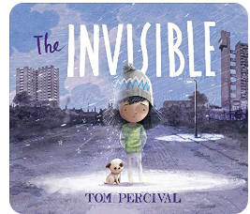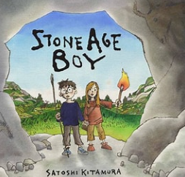  Outcomes:  Retell of the story  Diary  Instructions  First hand experiences:  Wildlife Trust – Stone age day experience  Key terminology:  noun, noun phrase, statement, question, exclamation, command, compound, suffix, adjective, adverb, verb, tense (past, present), apostrophe, comma |  | Key texts(s):  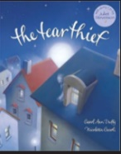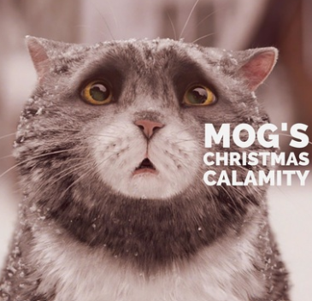  Outcomes:  Poem  Diary entry  Letter of explanation  Narrative from a different perspective  First hand experiences:  Key terminology:  conjunction, word family, prefix, direct speech, , inverted commas (or ‘speech marks’) adverbial |  | Key texts(s):  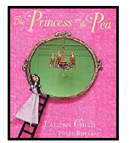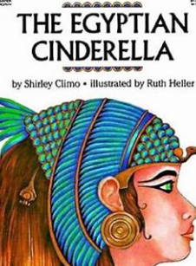  Outcomes:  News report  Diary entry  Character description  First hand experiences:  Key terminology:  preposition, consonant, consonant letter vowel, vowel letter
Writing skills  Place the possessive apostrophe accurately in words with regular plurals [for  example, girls’, boys’] and in words with irregular plurals [for example, children’s]  Write from memory simple sentences, dictated by the teacher, that include words and  punctuation taught so far.  Composition:  Plan their writing by:  -discussing writing similar to that which they are planning to write in order to  understand and learn from its structure, vocabulary and grammar  -discussing and recording ideas  Proof-read for spelling and punctuation errors |  | Writing skills  Use the first two or three letters of a word to check its spelling in a dictionary  Formation of nouns using a range of prefixes [for example super–,  anti–, auto–  Word families based on common words, showing how words are related in form and meaning [for example, solve, solution, solver, dissolve, insoluble  Composition:  Draft and write by:  -Composing and rehearsing sentences orally (including dialogue), progressively  building a varied and rich vocabulary and an increasing range of sentence  structures (English Appendix 2)  Creating settings, characters and plot  Proof-read for spelling and punctuation errors  Read aloud their own writing, to a group or the whole class, using appropriate  intonation and controlling the tone and volume so that the meaning is clear. |  | Writing skills  Use of the forms a or an according to whether the next word begins with a consonant or a vowel [for example, a rock, an open box]  Expressing time, place and cause using conjunctions [for example, when, before, after, while, so, because], adverbs [for example, then,next, soon, therefore], or prepositions [for example, before, after,  during, in, because of  Composition:  Draft and write by:  -Composing and rehearsing sentences orally (including dialogue), progressively  building a varied and rich vocabulary and an increasing range of sentence  structures (English Appendix 2)  Organising paragraphs around a theme  Creating settings, characters and plot  In non-narrative material, using simple organisational devices [for example,  headings and sub-headings  Proof-read for spelling and punctuation errors
Images from texts being used in this section |  | Images from texts being used in this section |  | Images from texts being used in this section
Spoken language  Reading links  develop positive attitudes to reading and understanding of what they read by:  -listening to and discussing a wide range of fiction, poetry, plays, non-fiction and  reference books or textbooks  -reading books that are structured in different ways and reading for a range of  purposes  Understand what they read, in books they can read independently, by:  -checking that the text makes sense to them, discussing their understanding and  explaining the meaning of words in context  - asking questions to improve their understanding of a text  Retrieve and record information from non-fiction  apply their growing knowledge of root words, prefixes and suffixes  Read further exception words, noting the unusual correspondences between spelling and sound, and where these occur in the word | GPS links  Handwriting:  Use the diagonal and horizontal strokes that are needed to join letters and understand which letters, when adjacent to one another, are best left unjoined  Grammar:  Indicating possession by using the possessive apostrophe with plural nouns  Noun phrases expanded by the addition of modifying adjectives, nouns and preposition phrases (e.g. the teacher expanded to: the strict maths teacher with curly hair)  Punctuation:  Use of capital letters, full stops, question marks and exclamation marks  to demarcate sentences  Commas to separate items in a list  Apostrophes to mark where letters are missing in spelling and to mark singular possession in nouns [for example, the girl’s name]  Using and punctuating direct speech  Spellings:  Words with the /k/ sound spelt ch (Greek in origin)  Words with the /ʃ/ sound spelt ch  (mostly French in origin)  Words ending with the /g/ sound spelt –  gue and the /k/ sound spelt –que (French in  origin)  Words with the /s/ sound spelt sc (Latin in origin)  Words with the /eɪ/ sound spelt ei, eigh, or ey  Homophones and near-homophones | Spoken language  Reading links  Using dictionaries to check the meaning of words that they have read  Recognising some different forms of poetry [for example, free verse, narrative  poetry]  Identifying themes and conventions in a wide range of books preparing poems and play scripts to read aloud and to perform, showing  understanding through intonation, tone, volume and action | GPS links  Handwriting:  Use the diagonal and horizontal strokes that are needed to join letters and understand which letters, when adjacent to one another, are best left unjoined  Grammar:  Using fronted adverbials  Using conjunctions, adverbs and prepositions to express time and cause  Punctuation:  Using commas after fronted adverbials  Spellings:  The /ɪ/ sound spelt y elsewhere than at the  end of words  More prefixes - un–, the prefixes dis– and mis–  have negative meanings, before a root word starting with m or  p, in– becomes im– re– means ‘again’ or ‘back’.  Words with endings sounding like /ʒə/ or  /tʃə/  Endings which sound like /ʒən/  The suffix –ous  Endings which sound like /ʃən/, spelt –tion,  –sion, –ssion, –cian | Spoken language  Reading links  Retrieve and record information from non-fiction  Predicting what might happen from details stated and implied  Retrieve and record information from non-fiction  Drawing inferences such as inferring characters’ feelings, thoughts and motives  from their actions, and justifying inferences with evidence | GPS links  Handwriting:  Use the diagonal and horizontal strokes that are needed to join letters and understand which letters, when adjacent to one another, are best left unjoined  Grammar:  Choosing nouns or pronouns appropriately for clarity and cohesion and to avoid  repetition  Punctuation:  Use of inverted commas and other punctuation to indicate direct  speech [for example, a comma after the reporting clause; end  punctuation within inverted commas: The conductor shouted, “Sit  down!”]  Spellings:  Adding suffixes beginning with vowel  letters to words of more than one  syllable  The /ʌ/ sound spelt ou  More prefixes - The prefix in– can mean both ‘not’  and ‘in’/‘into’. In the words given here it means ‘not’, sub– means ‘under’, nter– means ‘between’ or ‘among’. super– means ‘above’. anti– means ‘against’. auto– means ‘self’ or ‘own’.  Possessive  apostrophe with  plural words
Half term 4: Non-Fiction/Narrative |  | Half term 5: (Genre and text type) |  | Half term 6: (Genre and text type)
Key texts(s):  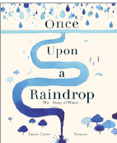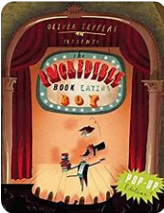  Outcomes:  Explanation text – how water is t=used throughout the school  Continuation of the plot  New viewpoint, same plot  First hand experiences:  Key terminology:  determiner, clause, subordinate clause, |  | Key texts(s):  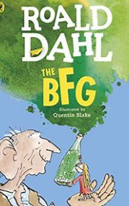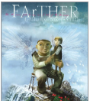  Outcomes:  First hand experiences:  Setting description – dream  New view point, same plot (Farther)  Same charaters, different plot – Farther  Key terminology: pronoun, possessive pronoun |  | Key texts(s):  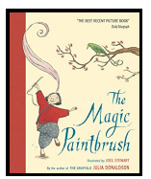  Outcomes:  Traditional tale using the same plotpoints  New viewpoint, same plot – The Iron Man  Big idea replicated to new story – Iron Lady on playground  First hand experiences:  Key terminology:
Writing skills  Place the possessive apostrophe accurately in words with regular plurals [for  example, girls’, boys’] and in words with irregular plurals [for example, children’s]  Write from memory simple sentences, dictated by the teacher, that include words and  punctuation taught so far.  Use the first two or three letters of a word to check its spelling in a dictionary  Increase the legibility, consistency and quality of their handwriting  Composition:  Draft and write by:  -Composing and rehearsing sentences orally (including dialogue), progressively  building a varied and rich vocabulary and an increasing range of sentence  structures (English Appendix 2)  Organising paragraphs around a theme  Creating settings, characters and plot  In non-narrative material, using simple organisational devices [for example,  headings and sub-headings  Evaluate and edit by:  assessing the effectiveness of their own and others’ writing and suggesting  improvements |  | Writing skills  Place the possessive apostrophe accurately in words with regular plurals [for  example, girls’, boys’] and in words with irregular plurals [for example, children’s]  Write from memory simple sentences, dictated by the teacher, that include words and  punctuation taught so far.  Use the first two or three letters of a word to check its spelling in a dictionary  Increase the legibility, consistency and quality of their handwriting  Composition:  Draft and write by:  -Composing and rehearsing sentences orally (including dialogue), progressively  building a varied and rich vocabulary and an increasing range of sentence  structures (English Appendix 2)  Organising paragraphs around a theme  Creating settings, characters and plot  Evaluate and edit by:  Proposing changes to grammar and vocabulary to improve consistency,  including the accurate use of pronouns in sentences |  | Writing skills  Place the possessive apostrophe accurately in words with regular plurals [for  example, girls’, boys’] and in words with irregular plurals [for example, children’s]  Write from memory simple sentences, dictated by the teacher, that include words and  punctuation taught so far.  Use the first two or three letters of a word to check its spelling in a dictionary  Increase the legibility, consistency and quality of their handwriting  Composition:  Draft and write by:  -Composing and rehearsing sentences orally (including dialogue), progressively  building a varied and rich vocabulary and an increasing range of sentence  structures (English Appendix 2)  Organising paragraphs around a theme  Creating settings, characters and plot  Evaluate and edit by:  assessing the effectiveness of their own and others’ writing and suggesting  improvements  Proposing changes to grammar and vocabulary to improve consistency,  including the accurate use of pronouns in sentences
Images from texts being used in this section |  | Images from texts being used in this section |  | Images from texts being used in this section
Spoken language  Reading links  Retrieve and record information from non-fiction  Predicting what might happen from details stated and implied  Retrieve and record information from non-fiction  Drawing inferences such as inferring characters’ feelings, thoughts and motives  from their actions, and justifying inferences with evidence  Discussing words and phrases that capture the reader’s interest and  imagination  ▪ recognising | GPS links  Handwriting:  Increase the legibility, consistency and quality of their handwriting  Grammar:  Standard English forms for verb inflections instead of local spoken forms [for example, we were instead of we was, or I did instead of I done]  Punctuation:  Apostrophes to mark plural possession [for example, the girl’s name,  the girls’ names]  Use of commas after fronted adverbials  Spellings:  The suffix –ation  Y3/4 Spellings | Spoken language  Reading links  Retrieve and record information from non-fiction  Predicting what might happen from details stated and implied  Drawing inferences such as inferring characters’ feelings, thoughts and motives  from their actions, and justifying inferences with evidence  Identifying main ideas drawn from more than one paragraph and summarising  these | GPS links  Handwriting:  Increase the legibility, consistency and quality of their handwriting  Grammar:  Extending the range of sentences with more than one clause by using a wider  range of conjunctions, including when, if, because, although  Punctuation:  Apostrophes to mark plural possession [for example, the girl’s name,  the girls’ names]  Use of commas after fronted adverbials  Spellings:  The suffix –ly  Y3/4 Spellings | Spoken language  Reading links  Retrieve and record information from non-fiction  Predicting what might happen from details stated and implied  Drawing inferences such as inferring characters’ feelings, thoughts and motives  from their actions, and justifying inferences with evidence  Identifying how language, structure, and presentation contribute to meaning | GPS links  Handwriting:  Increase the legibility, consistency and quality of their handwriting  Grammar:  Using the present perfect form of verbs in contrast to the past tense  Punctuation:  Apostrophes to mark plural possession [for example, the girl’s name,  the girls’ names]  Use of commas after fronted adverbials  Spellings:  Adding suffixes beginning with vowel  letters to words of more than one  syllable  Y3/4 Spellings

