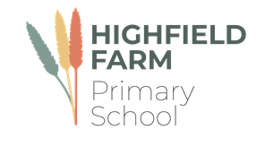

Class 3/4

Spring Term 2

This term sees us working on a variety of high-quality texts that are often linked together by common themes. The wonderful texts we are going to explore this term are:

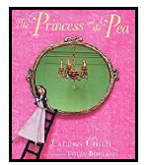 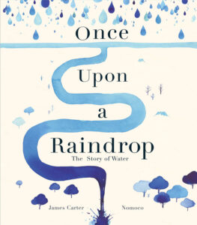 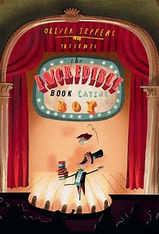

The table below describes what is happening in each of the subject areas.

|  |  |
| --- | --- |
| **English** | Our English lessons will focus around narrative writing and develop our confidence around writing stories. We will concentrate on building varied and rich vocabulary and increase the range of sentence types we use. |
| **Maths** | Much of this half term will revolve around **securing a strong understanding of fractions** as well as **mass and capacity.** This will be taught with concrete apparatus and pictures to support their thinking. |
| **Geography** | This half term we will be learning about **The South West of the UK.** The children will have r opportunities to develop geographical skills through engaging with sketch maps, aerial views, relief maps and Ordnance Survey maps. |
| **History** | This half term we will be learning about the Anglo-Saxons. The children will learn about the lives of people who lived in this period, how they lived, their homes, their jobs, what they ate and what they did for fun |
| **Music** | We use the Charanga scheme to support our learning in music. This half term our learning will be based on **‘The Dragon Song’** by Joanna Mangona and Pete Readman. This is a song about kindness, respect, friendship, acceptance and happiness. |
| **PE** | Please make sure that your children come to school dressed in **full PE kit to school every Wednesday and Thursday** including track suit bottoms and tops and suitable footwear. The children will be participating in a variety of fundamental movement skills and football. |
| **PSHE** | The main focus for this subject this half term is on **Healthy Me.** The children will learn about how diet and exercise impact their health. |
| **RE** | This half term the children will explore the question ‘**What is Good Friday all about?** We will learn about Easter and complete work around the theme of forgiveness. |
| **Computing** | Our focus for this term is on **Branching Databases.** The children will develop their understanding of what a branching database is and how to create one. They will use yes/no questions to gain an understanding of what attributes are and how to use them to sort groups of objects. |
| **DT** | This half term in DT the children will be making bread and a pasta dish. |

**Learning you could do at home**

Reading

Every week your child will have access to a reading book appropriate to their reading level. Please hear them read these books. The more often they read, the better they will get. We expect all our children to read a minimum of four times a week. Your child may also come home with links to phonics videos to further support their word reading ability and small speed sound booklets for them to practice their sound recognition. Please let us know how your child is reading at home via Dojo.

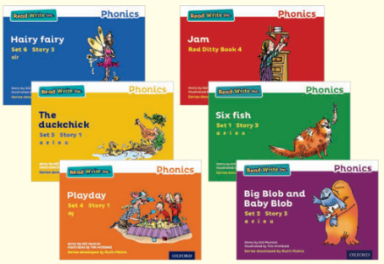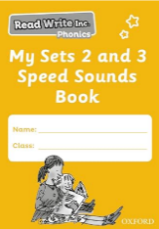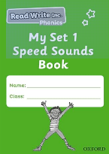

**Our school library**

The school has a library of books that the children can borrow from and enjoy at home. The books they choose are to be enjoyed by the whole family. These books may be too difficult for your child to read on their own and so we recommend that the books are read to them by an adult.

The school website also has a virtual library which has some recommended reads for all our children in virtual and video format. These books will be changed every half term.

**History at home**

Can you research the Battle of Hastings – share your research with the class. You could create a PowerPoint presentation or a poster of all the facts that you have learned.

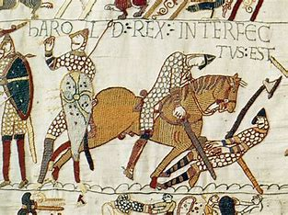

**DT at home**

Can you create a healthy pasta dish at home to share with your family? We would love to see your photos, send them via Class Dojo.

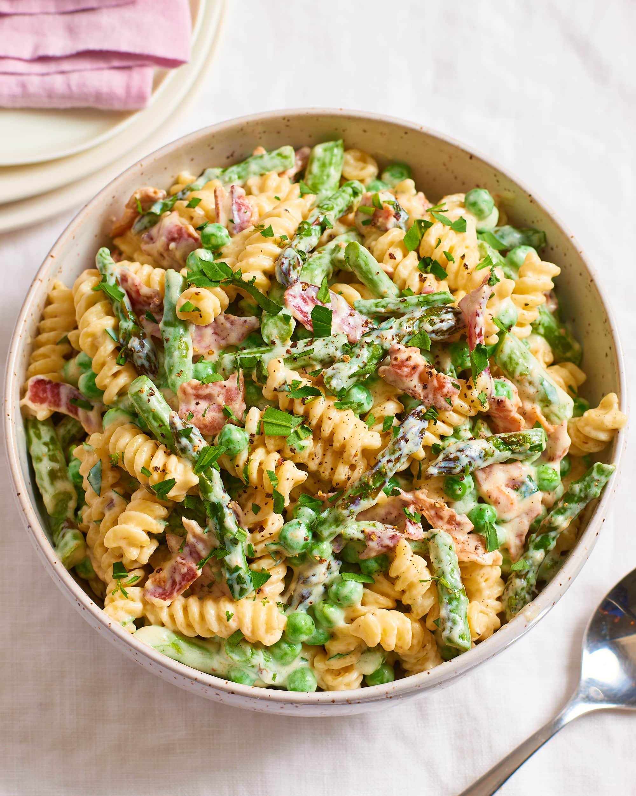

We would love to celebrate home learning, please send in any work or why not send us a photo on Dojo.