

**SEND Provision Highfield Farm Primary School**

*Together we will be kind, show respect and keep trying.*

***School Staff Expertise***

* *SENDCo*
* *Staff skilled in supporting autism and neurodiverse conditions*
* *Staff skilled in the delivery of speech and language programmes*
* *Team Teach trained members of staff*
* *Staff trained to deliver a range of strategies and interventions including Sensory Circuits and social stories*
* *Staff trained in SEMH and mental health*
* *Mental Health Lead*



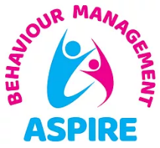

Highfield Farm Primary School has a high level of SEND at 36.1% (compared to 18% nationally) and Pupil Premium at 52% (compared to 23% nationally). We have 10 children with EHCPs in school and our attendance is 92.34%. The school’s catchment is socio-economically diverse with deprivation indicators for Health, Crime and Employment all in the lowest 20% nationally.

|  |  |  |  |  |
| --- | --- | --- | --- | --- |
| Implementation: School Steps to Success | | | | |
| Provision | Communication and Interaction | Cognition and Learning | Social, Emotional and Mental Health | Sensory and Physical |
| Universal  some children may need to be placed on the monitor list and BTK implemented | Quality First Teaching  Meeting with parents  Communication in Print  Same-day intervention.  Zones of Regulation | Quality First Teaching  Meeting with parents  Communication in Print  Same-day intervention  Zones of Regulation | Warm welcome  Quality First Teaching  Meeting with parents  Communication in Print  Same-day intervention  Zones of Regulation  Pastoral support | Quality First Teaching  Meeting with parents  Communication in Print  Same-day intervention  Zones of Regulation |
| Additional  Children may need BTK  added to send reg | Additional phonics intervention  Modified learning tasks  One Page Profile  Use of assistive technology (eg Clicker)  Early Help (if applicable)  Social Stories | One Page Profile  Use of assistive technology (eg Clicker)  Additional phonics  Small group Maths  Modified learning tasks  Early Help (if applicable) | One Page Profile  Boxall profile  Sensory Passport Sensory breaks/circuits  Early Help (if applicable)  Positive Handling Plan (if applicable) | One Page Profile  Sensory Passport Sensory breaks/circuits  Early Help (if applicable) |
| Targeted  Children may need BTK  added to SEND reg and SSP | As above and also:  Regular meetings with parents  SALT programmes  Teacher-devised specific interventions (supported by BTK)  Specific support for language and communication difficulties. (eg Barrier games) | As above and also:  Regular meetings with parents  Teacher-devised specific interventions. (Supported by BTK)  Published support programmes.  1:1 Phonics  Bespoke Maths  Bespoke Writing  Dyslexia Screening/BPVS assessment/Working Memory rating scale  Early Help if applicable. | As above and also:  Regular meetings with parents  Morning meet and greet and bespoke entry activity  Teacher-devised specific interventions (supported by BTK)  Social skills groups  Bonding through Play  Early Help if applicable. | As above and also:  Regular meetings with parents  Teacher-devised specific interventions  Sensory circuits  Early Help if applicable. | |
| Specialist  Children may need BTK or Engagement model | As above and also:  Fusion LSS  Autism SALT support  EPS  CAMHS | As above and also  Fusion LSS  EPS  SIT advice | As above and also:  Behaviour Support e.g. Aspire Outreach  EPS  Bereavement support | As above and also:  Occupational Therapy  Physio  Hearing and Visual Impairment Team | |

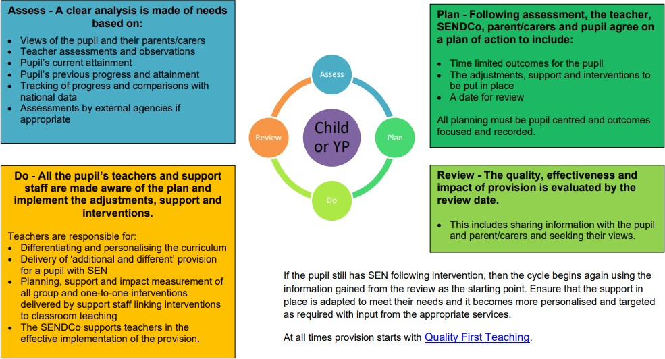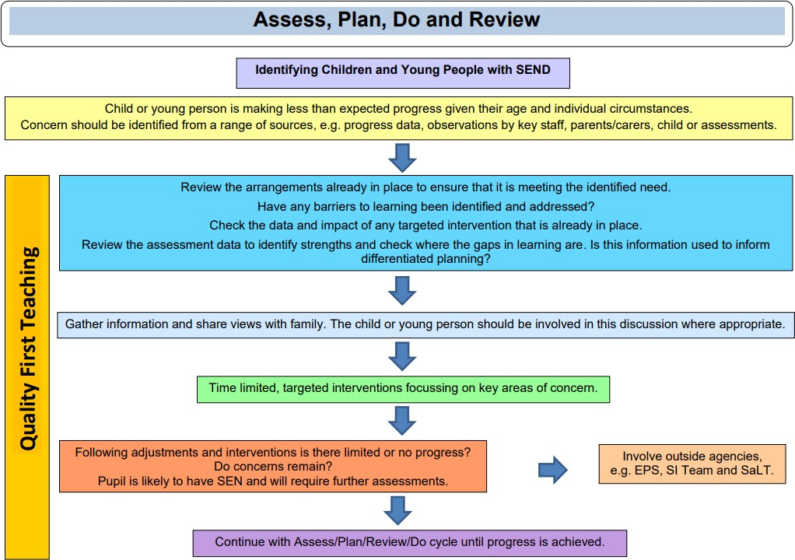

This term staff have received CPD in these areas of SEND:

* Zones of Regulation
* Birmingham Toolkit
* Evidence for Learning

**Impact:** As a result, Children at Highfield Farm:

* feel happy, safe and respected.
* Behaviour is good and diversity is celebrated.
* Children demonstrate high levels of engagement in activities, developing their speaking, listening and social skills.
* Have supportive and trained staff who make appropriate for the child’s individual needs. ·
* Children with SEND make good progress from their starting points due to Quality First Teaching and to the use of resources and bespoke small group intervention which meets the needs of the pupils.
* On leaving our school children with SEND have developed good independence and life skills. · Pupils will make secure transitions between classes and educational providers e.g. EYFS or High School.

***Intent****: Everyone at Highfield Farm Primary School is committed to, and passionate about, providing the conditions and opportunities to enable every child, including those with additional needs, to be included fully, in all aspects of school life. We believe in the earliest possible intervention to support our children and families. We always start with Quality First Teaching, for all children. If support is required beyond this, a graduated response is at the heart of our whole school ‘steps to success’ practice. We continually assess, plan, implement and review our approach to teaching and learning collaboratively with parents. We have highly skilled and trained staff to support any additional needs and use expert support from outside agencies where needed.*