

HIGHFIELD FARM PRIMARY SCHOOL

Maths Policy

Date of Policy approval _____________
Date of Policy review _______________

“The mathematician does not purely study mathematics because it is useful; they study it because they delight in it and they delight in it because it is beautiful.”

George Cantor

Statement of Intent
At Highfield Farm, we are committed to developing children’s curiosity along with the appreciation of the beauty and power of mathematics. Mathematics is a creative and highly inter-connected subject that has been the catalyst for solutions to some of history’s most significant and intriguing problems. It is essential to everyday life and necessary in most forms of employment, including engineering, medicine, information technology, finance and astronomy. It is our ambition for every pupil to become mathematically proficient, confident to explore connections and patterns, to seek solutions, to share their insights, understanding and reasoning. We aim to provide every pupil with a comprehensive mathematical education to ensure that they feel empowered and confident in their pursuits, ensuring more children secure and exceed the national standards. Our lessons are inclusive, engaging, challenging and supportive: enabling all pupils to participate and experience success in a safe and well-equipped learning environment. This enables our pupils to move on to the next stage of their learning well-prepared, ready for the next challenge and to succeed later in life in whatever career they choose.

The national curriculum for mathematics aims to ensure that all pupils:
• become fluent in the fundamental of maths
• are able to reason mathematically
• can solve a range of problems by applying their mathematical knowledge.

In line with three aims outlined by in the national curriculum statements above, we work flexibly with the White Rose scheme of learning. This ensures that pupils develop the confidence to apply their mathematical knowledge in a range of situations, use their sound knowledge to reason and consistently challenge themselves to fully realise their potential.
At Highfield Farm Primary School, we ensure that skills are embedded within Maths lessons and developed consistently over time. We are committed to ensuring that children are able to recognise the importance of Maths in the wider world and that they are also able to apply their mathematical skills and knowledge confidently in their lives in a range of different contexts.

Our mathematics curriculum is designed to provide our children with the language and vocabulary they need to reason and apply their thinking to everyday mathematical concepts. To this end, maths is one of the essential aspects of our curriculum which acts as a catalyst for our entire curriculum offer.
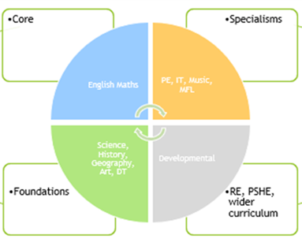

Implementation
Our mathematics curriculum has been developed to motivate and support every child to achieve excellence in mathematics. It provides pupils with a deep understanding of the subject to ensure pupils have a strong understanding of the learning taking place. We use the White Rose scheme of learning flexibly to plan maths across school. Long-term plans are used to ensure progression and coverage of the National Curriculum. Teachers may adapt the sequence and length of units of learning depending on the needs of their pupils and assessments. Teachers plan small steps of learning to structure the learning journey and assess the development of concepts, key skills and procedures. Lessons may include the following elements
• Teachers reinforce an expectation that all children are capable of achieving high standards in Mathematics.
• The majority of children progress through the curriculum content at the same pace; Significant time is spent developing deep knowledge of the key ideas that are needed to underpin future learning. This ensures that all children can master concepts before moving to the next part of the curriculum sequence, allowing no pupil to be left behind.
• If a pupil fails to grasp a concept or procedure, this is identified quickly and early intervention and responsive teaching time ensures the pupil is ready to move forward with the whole class in the next lesson.
• The structure and connections within the mathematics are emphasised, so that pupils develop deep learning that can be sustained.
• Lesson design identifies the new mathematics that is to be taught, the key points, the difficult points and a carefully sequenced journey through the learning. In a typical lesson children sit facing the teacher and the teacher leads back and forth interaction based around Voice 21 Oracy skills including questioning, short tasks, explanation, demonstration, and discussion. Lessons begin with a true of false question to support reasoning and Flashback four (a daily review of previous learning) and all new learning is broken into small, manageable steps with children being provided with opportunities for guided practice, supported by the teacher, before moving on to independent practice when they are beginning to feel more confident.
• Practice and consolidation play a central role. Carefully designed variation within this builds fluency and understanding of underlying mathematical concepts.
• Teachers use precise questioning in class to test conceptual and procedural knowledge and assess children regularly to identify those requiring intervention.
• Children’s explanations and their proficiency in articulating mathematical reasoning, with the precise use of mathematical vocabulary, are supported through the use of stem sentences provided by the teacher.
• Key facts such as multiplication tables and addition facts within 10 are learnt to automaticity as part of our daily arithmetic sessions supported by White Rose Fluency Bee in Key Stage 1 and Sarah Farroll materials in Key stage 2, to avoid cognitive overload in the working memory and enable pupils to focus on new concepts.

The White Rose curriculum is a cumulative curriculum, so that once a topic is covered, it is met many times again in other contexts. Mathematical topics are taught in blocks, to enable the achievement of ‘mastery’ over time. These teaching blocks are broken down into smaller steps, to help children understand concepts better. This approach means that children do not cover too many concepts at once which can lead to cognitive overload.

Teaching and Learning
Effective teaching for mastery is underpinned by five big ideas, first published by the National Centre for Excellence (NCETM) in mathematics in 2017 –
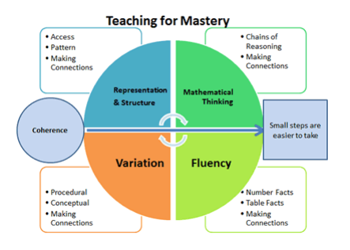
Source: https://www.ncetm.org.uk/teaching-for-mastery/mastery-explained/five-big-ideas-inteaching-for-mastery/

Maths is taught daily during the morning. A typical maths lesson lasts approximately 1 hour and begins with a short number fluency activity, Fluency Bee. The next part of the lesson is the Daily Review, where teachers review prior learning and address misconceptions. The small step for the lesson is then shared with the children and they revisit and learn key concepts following the CPA model.

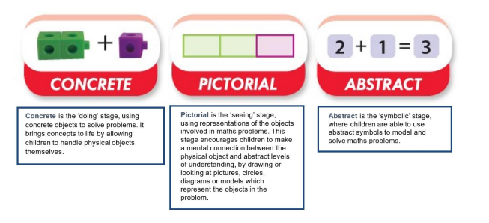
- The Daily Review part of the lesson (Flashback four) provides the means for the teacher to assess, review and revisit previous related content, so that all children are well prepared for new content.
- The ‘I do’ part of the lesson is when a new mathematical concept is introduced and modelled by the teacher.
- This is then followed by the ‘We do’ part of the lesson where the teacher uses guided practice to support children to practice and develop their confidence and understanding of the new skill. This means that children are then well prepared for the ‘You do’ part of the lesson where they independently apply the skills, knowledge and strategies taught.

Each classroom has a maths ‘help desk’ set up which is made up of a number of mathematical equipment stored easily accessible which children are encourages to use to support their learning.

Our Maths curriculum is designed to ensure that children retain knowledge by building upon previous learning. To enable children to retain as much knowledge as possible, teachers implement a number of strategies outlined by Barak Rosenshine’s research around the principles of instruction. These include:
- A daily review of previous learning at the beginning of each lesson.
- Presenting new material in small steps.
- Effective use of questioning to enable all children to practice new information
- Guided practice led by the teacher to ensure that all children have the opportunity to develop the new skill/concept. (I do, we do, you do)

Assessment

Assessment for Learning
Children receive effective feedback through teacher assessment, both orally and through written feedback, and AfL is integral to the design of each lesson;
- Observations and careful questioning enable teachers to adjust lessons and brief other adults in the class if necessary
- The structure of the teaching sequence, ensures that children know how to be successful in their independent work. A daily review/fluency activity supports children’s recall of key number facts, which frees working memory. Teachers use the information here to plan for and address misconceptions.
- Common misconceptions are identified and addressed within the teaching sequence and key understanding within each ‘small step’ is reviewed and checked by the teacher and the children before progression to further depth.
- The final phase of the lesson is a whole class reasoning True or False problem. Teachers use the children’s responses as a means to assess the depth of their understanding.
- At the end of the lesson, the children review their work and self and peer assessment are used consistently as outline by the school’s ‘Presentation, Marking and Feedback Policy’.

At the end of each blocked unit of work, the children also complete the carefully aligned White Rose Maths ‘End of Unit Assessment’ to assess the previously taught block. This is to support retrieval along with the outcome being used by the teacher to ensure that any identified gaps in understanding can be addressed.

Summative Assessment
Teachers administer a termly arithmetic paper and reasoning and problem-solving paper which specifically links to the coverage for that term. The results of these papers are used to identify children’s ongoing target areas, which are communicated to the children, as well as to parents and carers at Parents Evening. They are also used alongside the end of unit assessments and outcomes of work, to inform the whole school tracking of attainment and progress of each child. Assessment data in maths is reviewed throughout the year to inform interventions and to also ensure that provision remains well-informed to enable optimum progress and achievement. End of year data is used to measure the extent to which attainment gaps for individuals and identified groups of learners are being closed. This data is used to inform whole school and subject development priorities for the next school year.

Any child that is working below the expected standard is also assessed by the Birmingham Toolkit, which breaks the learning into smaller steps to allow children to close their gaps to ‘catch-up’.

Inclusion
Taking a mastery approach, differentiation occurs in the support and intervention provided to different children, not in the topics taught, particularly at earlier stages. The National Curriculum states:
‘Children who grasp concepts rapidly should be challenged through being offered rich and sophisticated problems before any acceleration through new content. Those who are not sufficiently fluent with earlier material should consolidate their understanding, including through additional practice, before moving on.’
There is little differentiation in the content taught but the questioning and scaffolding individual children receive in class as they work through problems will differ, with higher attainers challenged through more demanding problems, which deepen their knowledge of the same content before acceleration onto new content. Children’s difficulties and misconceptions are identified through immediate formative assessment and addressed with rapid intervention – commonly through individual or small group support later the same day or within the lesson.

A range of inclusion strategies, disseminated by the SENDCO, are embedded in practice and teachers are aware of the special educational needs of the children in their Maths class, as well as those who have English as an additional language. Although the expectation is that the majority of children will move through the programs of study at broadly the same pace, the 2014 National Curriculum states:
‘Decisions about when to progress should always be based on the security of children’s understanding and their readiness to progress to the next stage.’
If a child’s needs are best met by following an alternative plan, including coverage of the content from a previous year, this will be overseen by the SENDCO, in collaboration with the class teacher and with the knowledge of SLT. Specific arrangements for the provision of children with SEND will be communicated to parents and carers during SEND reviews.

The importance of vocabulary
Teachers use questioning, and provide opportunities for discussion and investigation to support the development of specific language and vocabulary, which is explicitly taught and modelled by teachers in every lesson. Key terms and sentence stems are identified on the White Rose Scheme of work and are taught and revisited frequently, to make learning memorable, relevant and easy to retrieve.

Oracy

The development of speaking and listening skills is increasingly recognised as a crucial component in mathematics education. Integrating oracy into mathematics, supported by the Voice 21 program, not only enhances students’ communication abilities but also deepens their conceptual understanding and problem-solving skills. At Highfield Farm we plan opportunities for children to learn through exploratory talk to deepen their understating of mathematical concepts and share ideas and strategies to support reasoning and problem-solving skills.

Impact
Highfield Farm has a supportive ethos and our approaches support the children in developing their collaborative and independent skills, as well as empathy and the need to recognise the achievement of others. Children can underperform in Maths because they think they cannot do it or are not naturally good at it. Our use of White Rose Maths addresses these preconceptions by ensuring that all children experience challenge and success in Maths and develop a growth mindset. It enables them to become more resilient and have high aspirations of themselves, believing that they can succeed.

Appendix – Rosenshine’s Principles of Instruction
